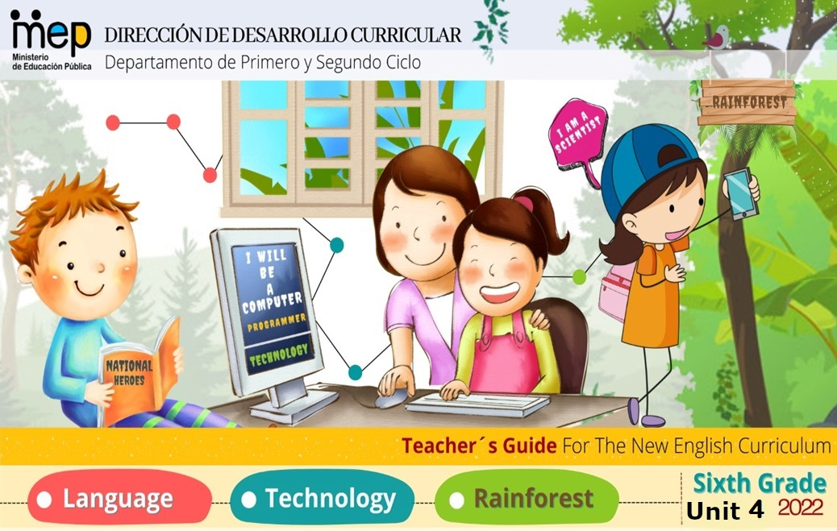

|  |  |  |  |  |
| --- | --- | --- | --- | --- |
| **Level 6th Unit 4 Rainforest Rescue**  **Scope and Sequence** | | | | |
| **Dimensions**  **1. Ways of thinking (X)**  **2. Ways of living in the world (X)**  **3. Ways of relating with others (X)**  **4. Tools for integrating with the world (X)** | | | | |
| **Scenario: Rainforest Rescue** | | | | |
| **Enduring Understanding** | **Enduring understanding:** Rainforests are tall, densely growing, broad-leaved evergreen trees in a tropical area with high annual rainfall. They recycle and clean water; protect against pollution and erosion, provide plants for food and medicine provide homes for many types of life forms. Rainforests are quickly being cut down mostly for wood to build houses and roads as well as making space for cattle raising and farming. | | | |
| **Essential  Question** | What are rainforests and what happens if they disappear? | | | |
| **Assessment and Goals** | | | | |
| **Week 1** | **Week 2** | **Week 3** | **Week 4** | **Week 5** |
| **Theme**   1. The Rainforest: a Treasure | **Theme**  2. Are We Saying “Goodbye” to the Rainforest? | **Theme**  3.Ways to Rescue It | **Theme**  4.My Role in the Rainforest Rescue |  |
| **Assessment:**  **L.1** Recognizes simple procedural explanations if given slowly and clearly.  **R.PA.3.** Reads with fluency and accuracy.  **SP.2.** Provides a simple description of a studied object  **Goals:**  **L.1.** understand simple procedural explanations if given slowly and clearly, and opportunity is given for clarification (e.g., how to create a project).  **R.PA.3.** read with fluency and accuracy.  **SP.2.** provide a simple description of a studied object (e.g., describe a rainforest). | **Assessment:**  **L.2.** Recognizes the general idea of overheard conversations.  **R.PA.3.** Reads with fluency and accuracy.  **SI.1.** Asks other students to confirm solutions to problems.  **W.2.** Devises a timeline for a topic.  **Goals:**  **L.2.** comprehend the general idea of overheard conversations.  **R.PA.3.** read with fluency and accuracy.  **SI.1.** ask other students to confirm solutions to problems.  **W.2.** devise a timeline for a topic. | **Assessment:**  **L.1** Recognizes simple procedural explanations if given slowly and clearly.  **R.PA.4.** Distinguishes between sounds /v / b/ in words.  **SP.1.** Describes, using simple words, their opinion of a situation or event.  **W.1.** Engages in the writing process during pre-writing, drafting, editing and simple publications.  **Goals:**  **L.1** Recognize simple procedural explanations if given slowly and clearly.  **R.PA. 4.** demonstrate knowledge of phonemic awareness.  **SP.1.** describe, using simple words, their opinion of a situation or event.  **W.1.** engage in the writing process during pre-writing, drafting, editing and simple publications. | **Assessment:**  **R.1.** Recognizes readings, analyzes and enjoys texts.  **R.PA.3.** Reads with fluency and accuracy  **W.3.** Applies conventions of standard English (e.g., advertisement, labeling a photo essay).  **Goals:**  **R.1.** comprehend reading, analyze and enjoy texts.  **R.PA.3.** read with fluency and accuracy.  **W.3.** apply conventions of standard English | **Assessment**  **Instruments for Process/Product**  **Week 6**  **Suggested Integrated Mini project** |
| **Function**    * Describing places and things | **Function**   * Describing the condition of the rainforests | **Function**   * Describing cause effect relationships | **Function**   * Giving advice |
| **Discourse Markers**  Linkers: Sequence adverbs-past tense  First, next, then, finally | **Discourse Markers**  Linkers: Sequence adverbs-past tense  First, next, then, finally | **Discourse Markers**  Linkers: Sequence adverbs-past tense  First, next, then, finally | **Discourse Markers**  Linkers: Sequence adverbs-past tense  First, next, then, finally |
| **Grammar & Sentence Frames**  Verb forms (present and past tense)   * A rainforest is a living ecosystem. * Rainforests are warm and wet forests. * Rainforests grow in mountain regions. * I saw lots of insects.   Simple present and simple past using (S+V+O+PP) pattern.   * The boy saw a toucan in a tree. * The guide drove the tourists through the rainforest. * The woman went into the rain forest. | **Grammar &Sentence Frames**    Adjectives (different types)   * Some trees live for a hundred years. * Huge trees live in a rainforest. * You see that little light gets across the canopy. * Some trees drop their leaves.   Wh information  questions in present  tense   * Why are rainforests important? * What can we do to rescue the rainforest? * What causes harm to the rainforest?   Simple present using (S+V+PP) pattern   * Different species live in the rain forest. * Ferns grow in the rainforest. * Rainforests are in different parts of the country. | **Grammar & Sentence Frames**  Comparative and superlative forms   * Eating food grown in a sustainable way is (good, better, best) for the rainforest. * Learning about the rainforest is (good, better, best) for students. * Using palm oil is (bad, worse, worst) for the rainforest. | **Grammar & Sentence Frames**  Sequencing adverbs with can and should   * First, you should save water. * Next, you can educate people. * Then, you should plant trees. * Finally, we should recycle. |
| **Phonemic Awareness**  **Phonemic Awareness**  Sequencing event using transition words in a sentence frame (e.g., first, next, finally). | **Phonemic Awareness**  **Phonemic Awareness**  Sequencing event using transition words in a sentence frame (e.g., first, next, finally). | **Phonemic Awareness**  **Phonemic Awareness**  Practicing minimal pair sounds**: v / b**  **vote / boat**  **very / berry**  **van / ban**  **vest / best**  **vet / bet**  **vat/bat** | **Phonemic Awareness**  **Phonemic Awareness**  Practicing silent letters (kn, wr, gn) |
| **Vocabulary**  **1.** The Rainforest: a treasure  Verb forms (simple present and simple past tense)   * Be * Have * See   Nouns   * Rainfall * Climate * Flora and fauna * Canopy * Species   Adjectives   * Warm * Dense * Exotic * Tropical * Dark   Climate   * Humid * Cloudy * Rainy | **Vocabulary**  **2.** Are we saying “Goodbye” to the Rainforest?  Threats (nouns)   * Urbanization * Deforestation * Irresponsible tourism * Road construction * Hunting * Pollution * Wildfires   Verb forms   * Cut down * Damage * Destroy * Build * Cause | **Vocabulary**  **3.** Ways to Rescue It  Verb forms   * Protect * Value * Educate * Plant * Save * Use   Adjectives   * Endangered * Sustainable * Less   Nouns   * Biodiversity * Landscape * Wildlife * Paper | **Vocabulary**  **4.** My Role into the Rainforest Rescue.  Verb forms   * Make a plan * Reduce * Reuse * Recycle * Save (water) * Print (on both sides) * Tell * Donate * Learn   Nouns   * Class/community projects * Species * Money   Time |
| **Psycho-social**   * Differentiating intrinsic and extrinsic motivations to take care of the rainforest   **Sociocultural**   * Showing respect and politeness for others’ feelings and opinions   **Idioms/phrases**   * Take care of the earth and she will take care of you. | **Psycho-social**   * Discriminating between instrumental and integrative reasons to rescue the rainforest (personal benefit vs. community benefit)   **Sociocultural**   * Sharing experiences and concerns about the rainforest current situation   **Idioms/phrases**   * Take care of the earth and she will take care of you. | **Psycho-social**   * Discriminating between instrumental and integrative reasons to rescue the rainforest (personal benefit vs. community benefit) * Expressing ethical and moral values when making decisions related to rainforest preservation   **Sociocultural**   * Sharing experiences and concerns about the rainforest current situation * Using expressions of belief via graffiti, t-shirt slogans and catch phrases   **Idioms/phrases**   * Show your care, do your share * Save the planet. | **Psycho-social**   * Discriminating between instrumental and integrative reasons to rescue the rainforest (personal benefit vs. community benefit) * Expressing ethical and moral values when making decisions related to rainforest preservation   **Sociocultural**   * Using expressions of belief via graffiti, t-shirt slogans and catch phrases   **Idioms/phrases**   * Show your care, do your share * Save the planet. |  |

|  |  |  |  |  |  |  |  |
| --- | --- | --- | --- | --- | --- | --- | --- |
| **Term: 2** | | **Level: Sixth Grade** | | **Unit: 4** | **Week:1** | | |
| **Domain: Socio-interpersonal** | | | **Scenario: Rainforest Rescue** | | | **Theme:** The Rainforest: a Treasure | |
| **Enduring Understanding**: Rainforests are tall, densely growing, broad-leaved evergreen trees in a tropical area with high annual rainfall. They recycle and clean water; protect against pollution and erosion, provide plants for food and medicine provide homes for many types of life forms. Rainforests are quickly being cut down mostly for wood to build houses and roads as well as making space for cattle raising and farming. | | | | | | | |
| **Essential Question:** What are rainforests and what happens if they disappear? | | | | | | | |
| **Dimensions**  **1. Ways of thinking ( X )**  **2. Ways of living in the world ( X )**  **3. Ways of relating with others ( X )**  **4. Tools for integrating with the world ( X )** | | | | | | | |
| **Learn to Know** | | | **Learn to Do** | | | **Learn to Be and Live in Community** | |
| **Grammar & Sentence Frames**  Verb forms (present and past tense)   * A rainforest is a living ecosystem. * Rainforests are warm and wet forests. * Rainforests grow in mountain regions. * I saw lots of insects.   Simple present and simple past using (S+V+O+PP) pattern.   * The boy saw a toucan in a tree. * The guide drove the tourists through the rainforest. * The woman went into the rain forest.   **Phonemic Awareness**  Sequencing event using transition words in a sentence frame (e.g., first, next, finally).  **Vocabulary**  **1.** The Rainforest: a treasure  Verb forms (simple present and simple past tense)   * Be * Have * See   Nouns   * Rainfall * Climate * Flora and fauna * Canopy * Species   Adjectives   * Warm * Dense * Exotic * Tropical * Dark   Climate   * Humid * Cloudy * Rainy | | | **Function**   * Describing places and things   **Discourse Markers**  Linkers: Sequence adverbs-past tense  First, next, then, finally | | | **Psycho-social**   * Differentiating intrinsic and extrinsic motivations to take care of the rainforest   **Sociocultural**   * Showing respect and politeness for others’ feelings and opinions   **Idioms/ phrases**   * Take care of the earth and she will take care of you. | |
| **Assessment Strategies & Evidences of learning**  (Diagnostic, formative, summative) | **Goals** | | **Pedagogical Mediation/ Didactic Sequence** | | | | **Time** |
| Learner… | Learner can | | **Pre-teaching**  Routine: Checking attendance, checking in with Ls, T posts the Essential Question and Enduring Understanding and talks with the students about both of them. T shares the class agenda, etc. on the board  **Warm up**   * The teacher will paste some flashcards (Annex 1) on the whiteboard, related to the new vocabulary and the class is divided in 3 groups. Each group will take turns to say as many words as they can, as a game. The teacher will copy the words on the whiteboard. Some of them are: Rainfall, climate, flora and fauna, canopy, species.   **ACTIVATION OF PRIOR KNOWLEDGE**   * There are four different charts:   1. Verb forms in present and past tense, to be - was, to have - had, to see - saw.   2. Nouns: ranforest, clmate, flora, fauna, canopy, species.   3. Climate: humid, cloudy, rainy.   4. Adjectives: warm, dense, exotic, tropical, darkThe teacher shows students some pictures (Annex 2) and names them to exemplify the concepts below. Students will listen to them, while pointing to the one they hear:   **MODELING** The class will watch the video Procedural Text – Recipe. In the following link, you will find a video about how to write a procedural text: <https://www.youtube.com/watch?v=2hR3TuYhXSE>, so the students will be able to learn what a procedural text or explanation is. Teacher writes some sentences that exemplify a procedure, using the vocabulary presented on the previous section. Students come to the board and complete some of the sentences the teacher has written for them. For example:   * First, we went to a rainforest. * Then, my father said: A rainforest is a living ecosystem. * Rainforests are warm and wet forests. * Next, he explained that rainforests grow in mountain regions. * Finally, I saw lots of insects.   **CLARIFYING**  Students, working in a worksheet, unscramble some sentences that include the vocabulary modeled on the previous section. Once they have finished, students compare their answers with their partners and provide feedback if needed (Annex 3).  The students will unscramble some sentences that include the vocabulary: 1. was  -  flying.  -  The  -  tucan 2. is  -  forest  -  The  -  humid. 3.  There  -  may  -  are  -  species. 4. Sloths  -  exotic  -  are  -  animals. 5. dense.  -  is  -  The  -  forest | | | | 40 minutes |
| **L.1** Recognizes simple procedural explanations if given slowly and clearly.  **L1.1.** identifies simple procedural explanations about the rainforest if delivered slowly and clearly.  **L1.2** recognizes simple procedural explanations about the rainforest if delivered slowly and clearly. | **L.1.** understand simple procedural explanations if given slowly and clearly, and opportunity is given for clarification (e.g., how to create a project). | | **PRE-TASK** The teacher introduces the goal of the lesson.In the following link, you will find the video “How can we help protect the rainforests?” [https://www.youtube.com/watch?v=gTKzoMuW-s4](https://www.youtube.com/watch?v=gTKzoMuW-s4%20) . (Annex 4), Students watch the video, and the teacher plays it back and pauses it on specific frames to comment on the information snippets, and sentences. Seven different pictures that represent the following vocabulary: 1. Habitat. 2. Deforestation. 3. Replanting. 4 ree selection. 5. Ecotourism. 6. Rainforest in danger. 7. Education.  **TASK-REHEARSAL**  Students will watch for a second time the video “How can we help protect the rainforests?” [https://www.youtube.com/watch?v=gTKzoMuW-s4](https://www.youtube.com/watch?v=gTKzoMuW-s4%20) . Then, students identify simple procedural explanations about the rainforest used in the video by matching each statement with their corresponding icon. (Annex 5)  Seven pictures for students to match statements with icons. Pictures are: 1. a monkey, 2. deforestation, 3. education, 4. replanting, 5. tree selection, 6. ecotourism, 7, rainforest. Procedural explanation: 1- Deforestation is a problem for the rainforest. 2- It is the habitat of many species of animals and plants 3- The rainforest is endangered. We can help the rainforest by : 4- First, replanting trees. 5- Then, educating new generations about the rainforest. 6- After that, promoting ecoturism as a mean of preservation. 7- Finally, we should select the trees we are planting carefully.  **TASK COMPLETION**  Task: You will have a conversation in class about the rainforest. Your part in the conversation is to talk about ways to protect the rainforest. To prepare your presentation, you have to answer the questions below.  Students watch the video one more time to recognize simple procedural explanations about the rainforest by answering the following questions copied on the whiteboard by the teacher:   1. What is the first step to save rainforests? 2. To deforest is a second step to save rainforests? 3. Do you think education is an important step to save rainforests? 4. Can we plant all kinds of trees?   **TASK ASSESSMENT**  Students listen to the text read by the teacher and set it in order using the adverbs of frequency "First, Then, Next and Finally". (Annex 6)  A handout with texts with blank spaces at the beginning for students to complete with sequencers: First, Then, Next and Finally. | | | | 40 minutes |
| **R.PA.3.** Reads with fluency and accuracy. | **R.PA.3.** read with fluency and accuracy. | | **PRE-TASK**  The teacher introduces the goal of the lesson. In the following link, you will find a video of a song concerning Costa Rican Rainforest <https://www.youtube.com/watch?v=QbhCpfxsod8>. After watching the video, teacher plays it back and pauses it on specific frames to comment how they recognize some of the main vocabulary, and clarifying concepts.    **TASK-REHEARSAL**  The students read the lyrics of the song twice in a coral reading lead by the teacher.  Then, they will highlight the words they find familiar. (Annex 7)  Lyrics of the song Save the Americans  **TASK COMPLETION**  **Task**: You and a classmate want to participate in the English Festival at school. You will practice the song about the rainforest for a presentation.  Students listen to the song one more time and fill in the blanks with the vocabulary from the word bank. In pairs the students will practice the reading to reinforce their fluency and accuracy. (Annex 8)  A fill in the blanks exercise based on the song just presented.  **TASK ASSESSMENT**  The students read a sentence of the lyrics, with fluency and accuracy to make it comprehensible. | | | | 40 minutes |
| **SP.2.** Provides a simple description of a studied object  **SP.2.1.** brainstorms high frequency vocabulary and phrases to describe the rainforest.  **SP.2.2.** describes with simple vocabulary and sentences the rainforest. | **SP.2.** provide a simple description of a studied object (e.g., describe a rainforest). | | **PRE-TASK** The teacher introduces the goal of the lesson.In the following link, you will find a video about the layers of the Rainforest [**https://www.youtube.com/watch?v=7gHXoDPHTLw**](https://www.youtube.com/watch?v=7gHXoDPHTLw)**A worksheet with sentences of the new vocabulary to use in conversations.**Students watch the video while the teacher pauses it on specific frames to have a conversation on the information snippets in an oral way to clarify the vocabulary and sentence frames (Annex 9). **TASK-REHEARSAL**  Individually, students make a list of the most relevant vocabulary and phrases that were used in the video.  Students get in pairs and compare their lists of words.  Now, using the brainstormed words and phrases, students complete the information missing in an illustration based on the video that they watched in the previous section. Teacher can play the video while students complete this task. (Annex 10)  **A handout based on the information from the video watched to help students to have an interview.**  **TASK COMPLETION**  Based on the previous vocabulary and phrases, students will get ready to complete a **task**. The teacher tells them that they were invited to talk to a group of students from another country about Costa Rica´s rainforest. They are going to be the experts concerning the different layers that form the rainforest, and they are going to describe the rainforest to them before they go on an actual trip. In order to be ready for the presentation, students can complete the questionnaire below. (Annex 11)  A handout with some questions related to the topic of the unit.  **TASK ASSESSMENT**  Students volunteer to present to the rest of the classroom. | | | | 40 minutes |
| **Integrated Mini-Project** | | | | | | | **Time** |
| Phase: \_\_1\_\_\_\_\_  The students will work on groups can make a:   1. Mini book 2. Power point presentation 3. Poster 4. Model or mock up   Or any other tool they choose to present about the different aspects of the rainforest studied in the unit to the rest of the class.   1. On this first week they will choose the type of activity that they will do as a project (you as teacher can give them ideas for them to choose) and the tool. | | | | | | | 40 minutes |
| **Reflective Teaching** | | | | | | | |
| What worked well | | | What didn’t work well | | | | How to improve |
| **Enduring Understanding Reflection** | | | | | | | |
|  | | | | | | | |

|  |  |  |  |
| --- | --- | --- | --- |
| **Learner Self-Assessment** | | | |
| ***I can*** | ***Happy face icon with thumbs up.***  ***Achieved*** | ***A happy face.***  ***In progress*** | ***A sad face icon.***  ***Not achieved yet*** |
| **L1.1.** identify simple procedural explanations about the rainforest if delivered slowly and clearly. |  |  |  |
| **L1.2** recognize simple procedural explanations about the rainforest if delivered slowly and clearly. |  |  |  |
| **R.PA.3.** Read with fluency and accuracy. |  |  |  |
| **SP.2.** Provides a simple description of a studied object |  |  |  |

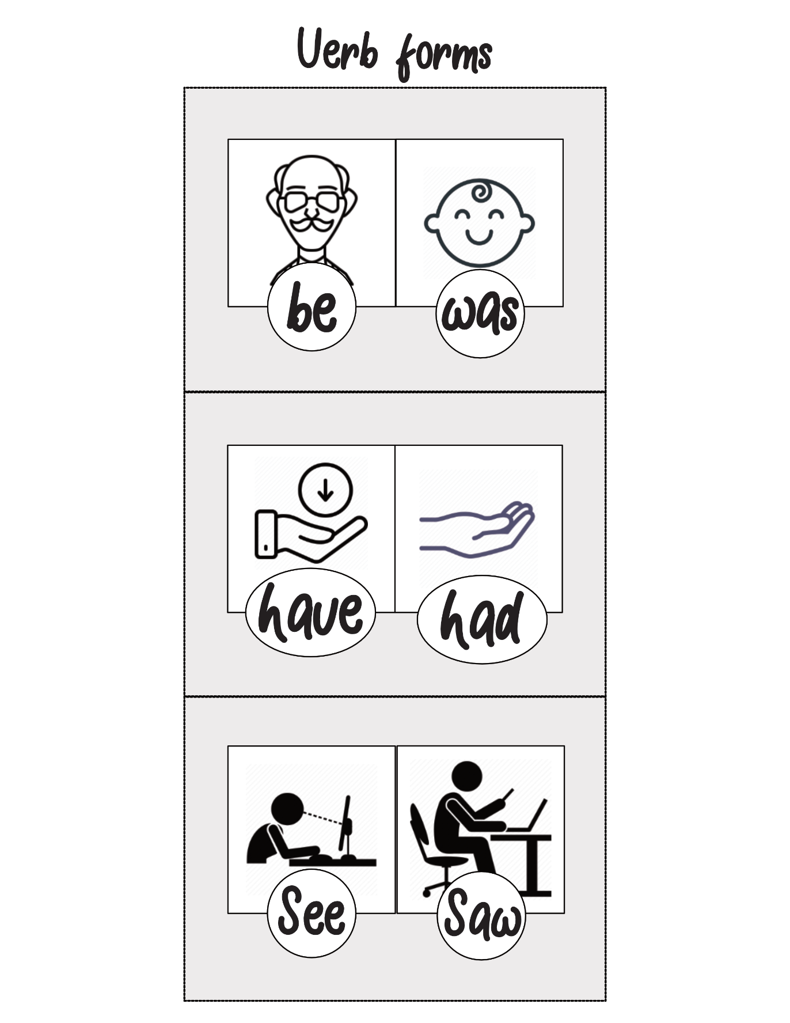Annex 1: Flashcards

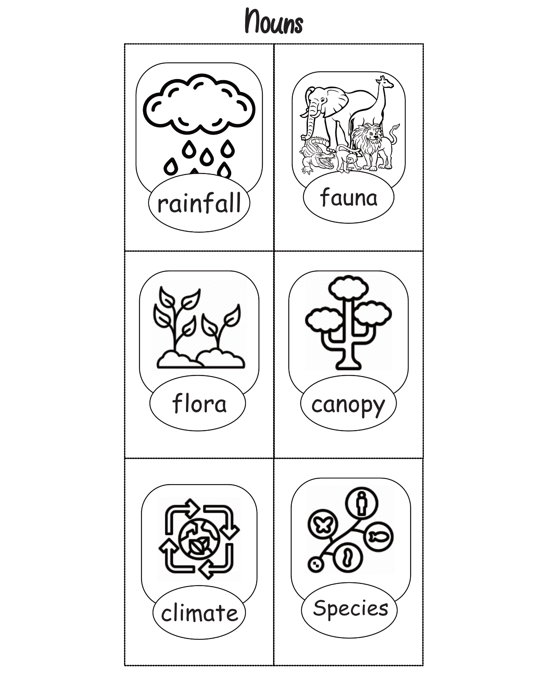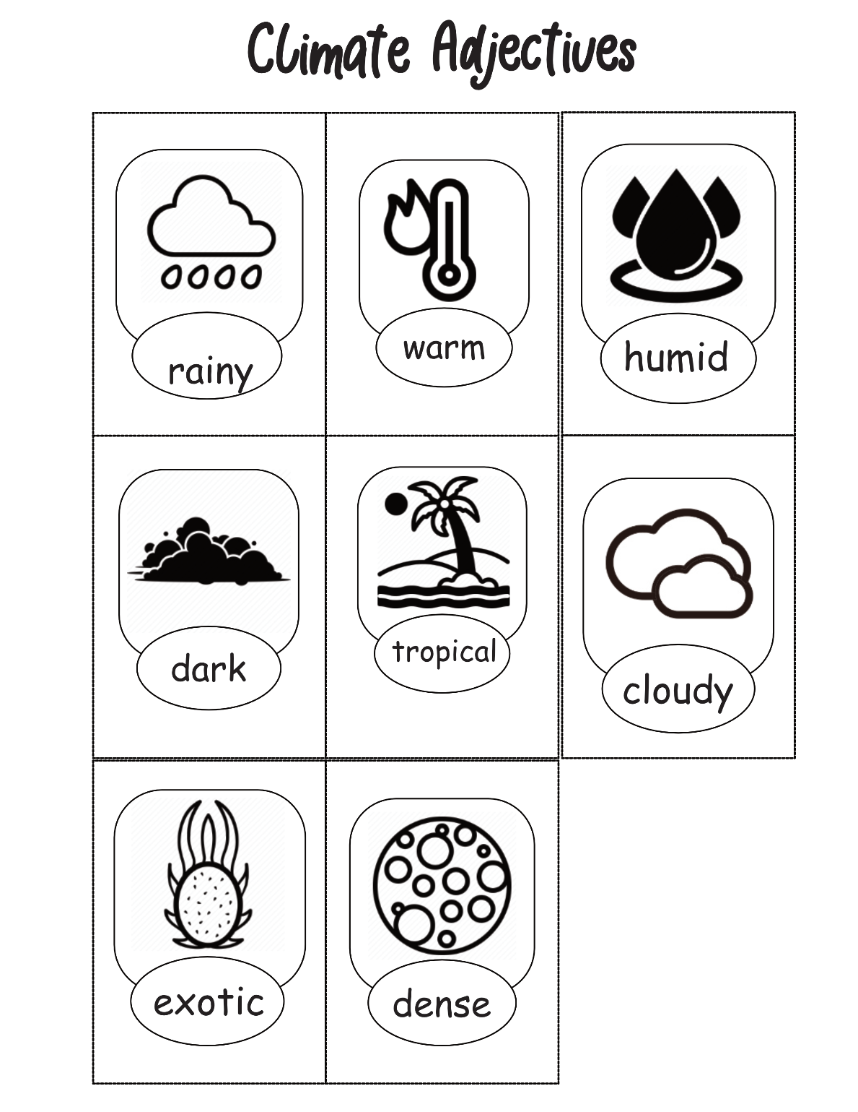

Annex 2

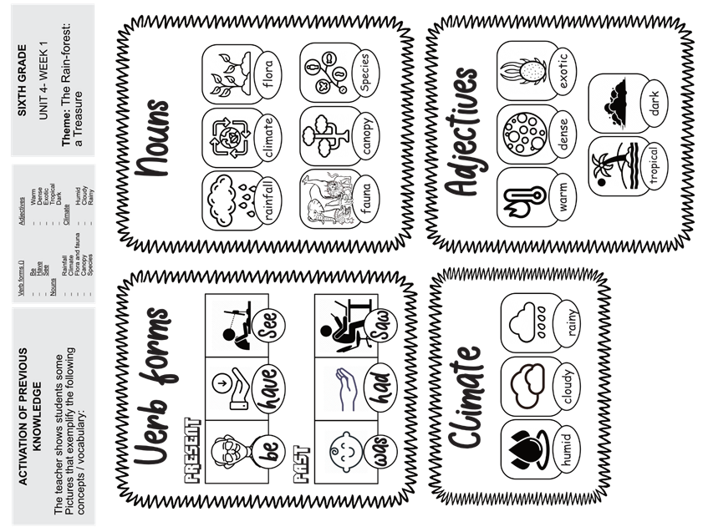

Annex 3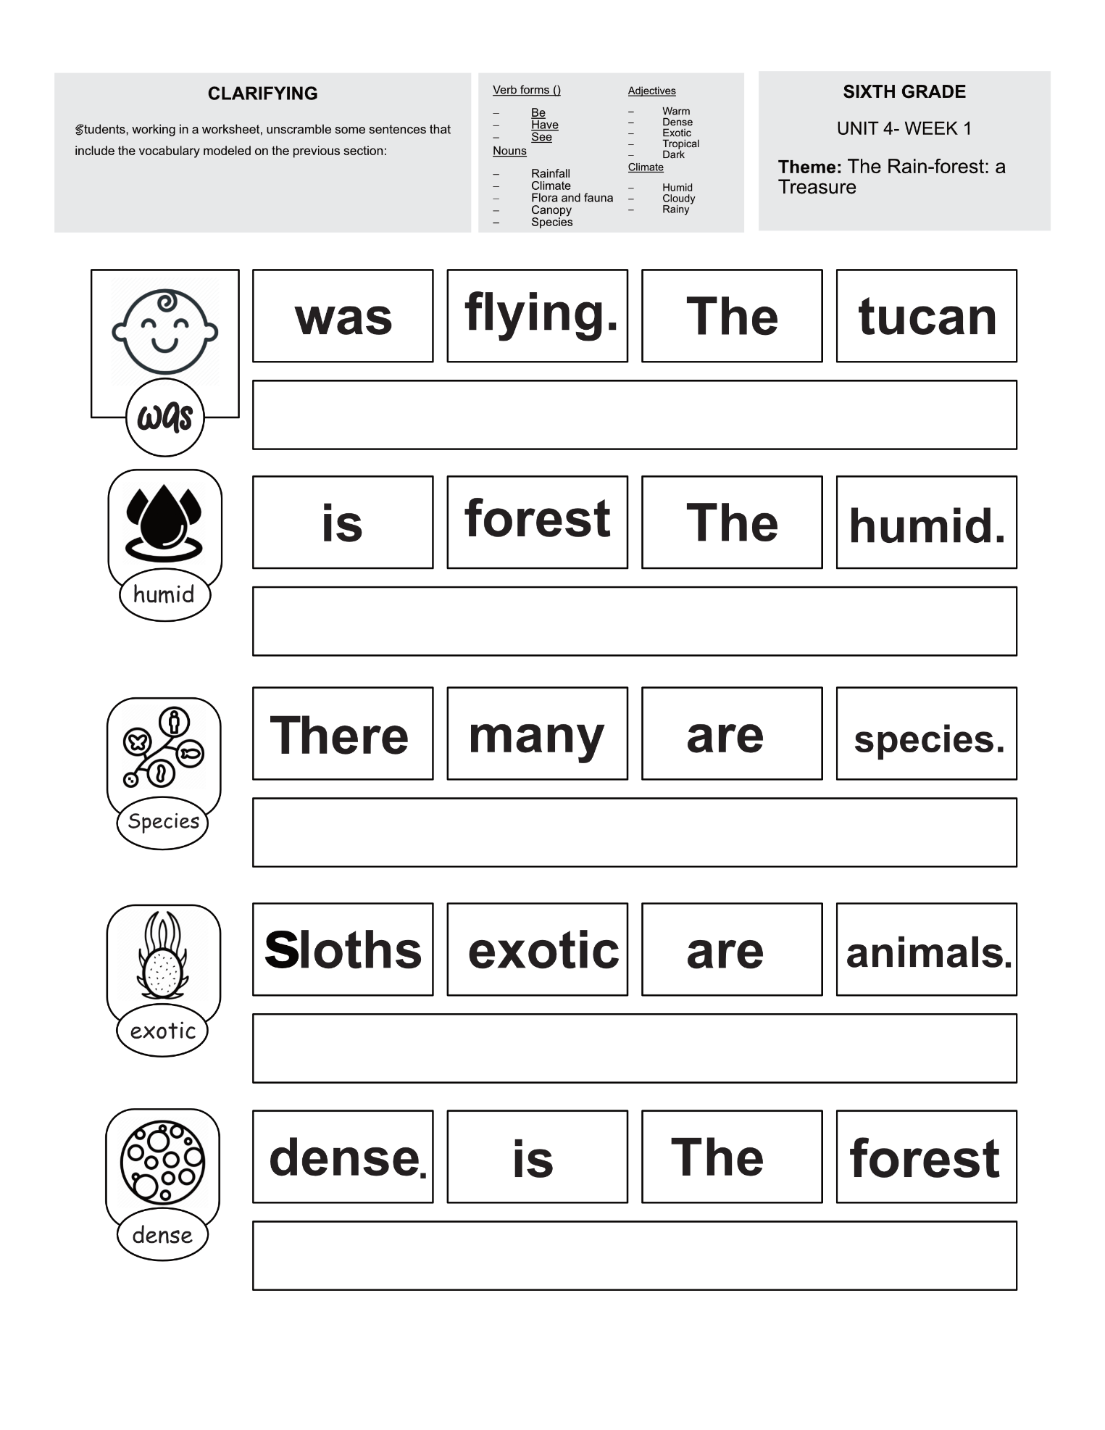

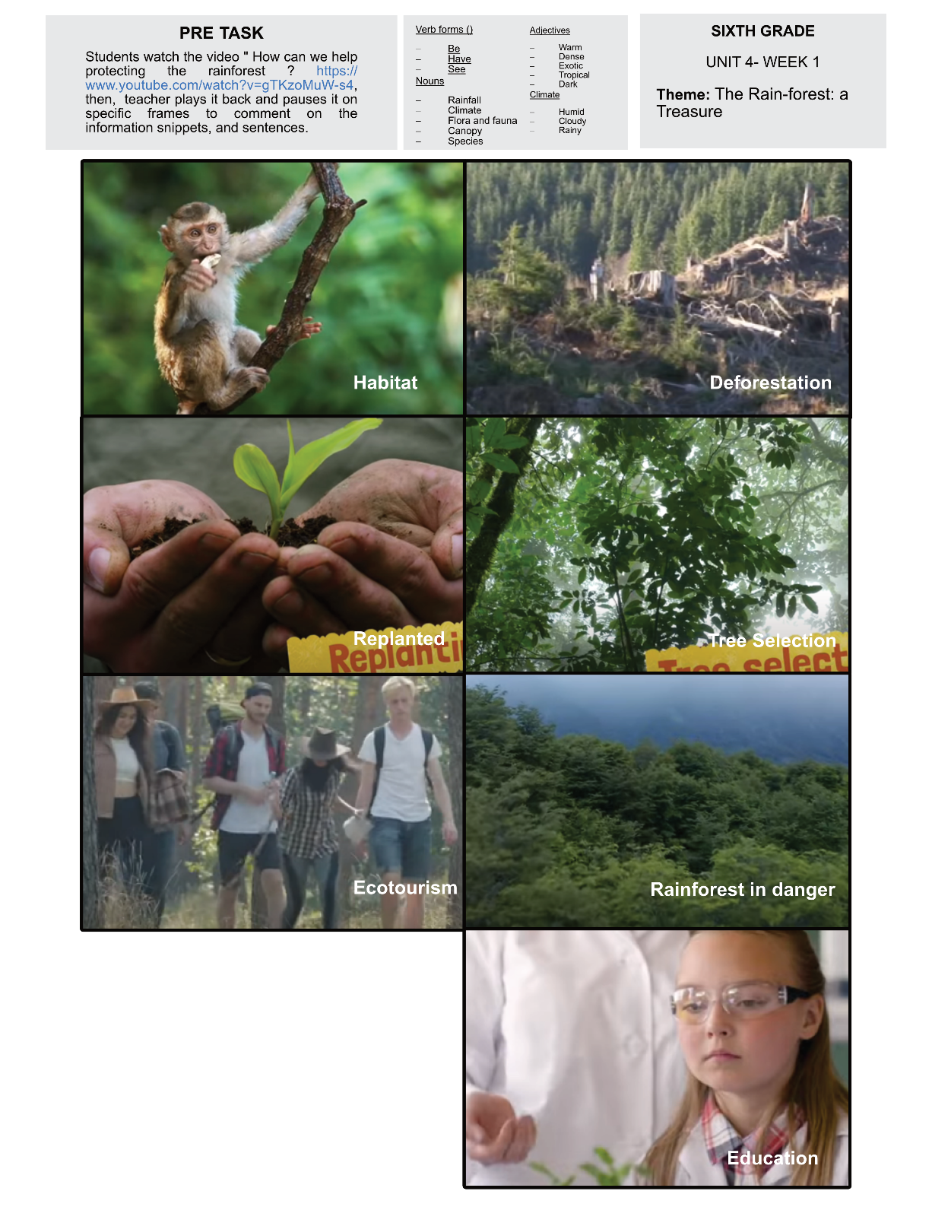Annex 4

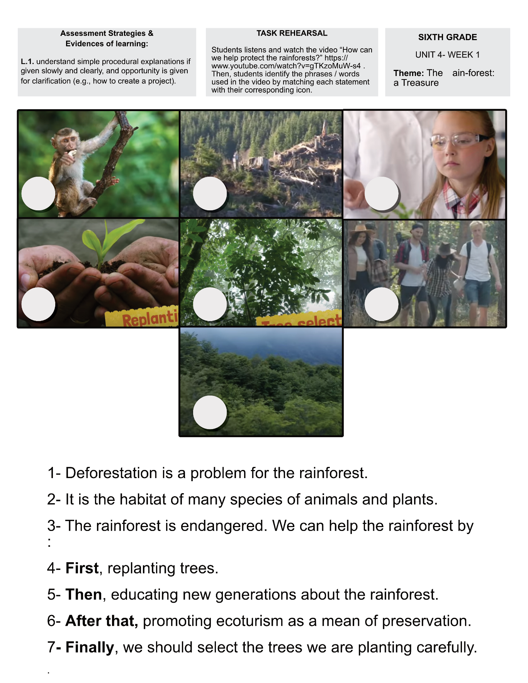Annex 5

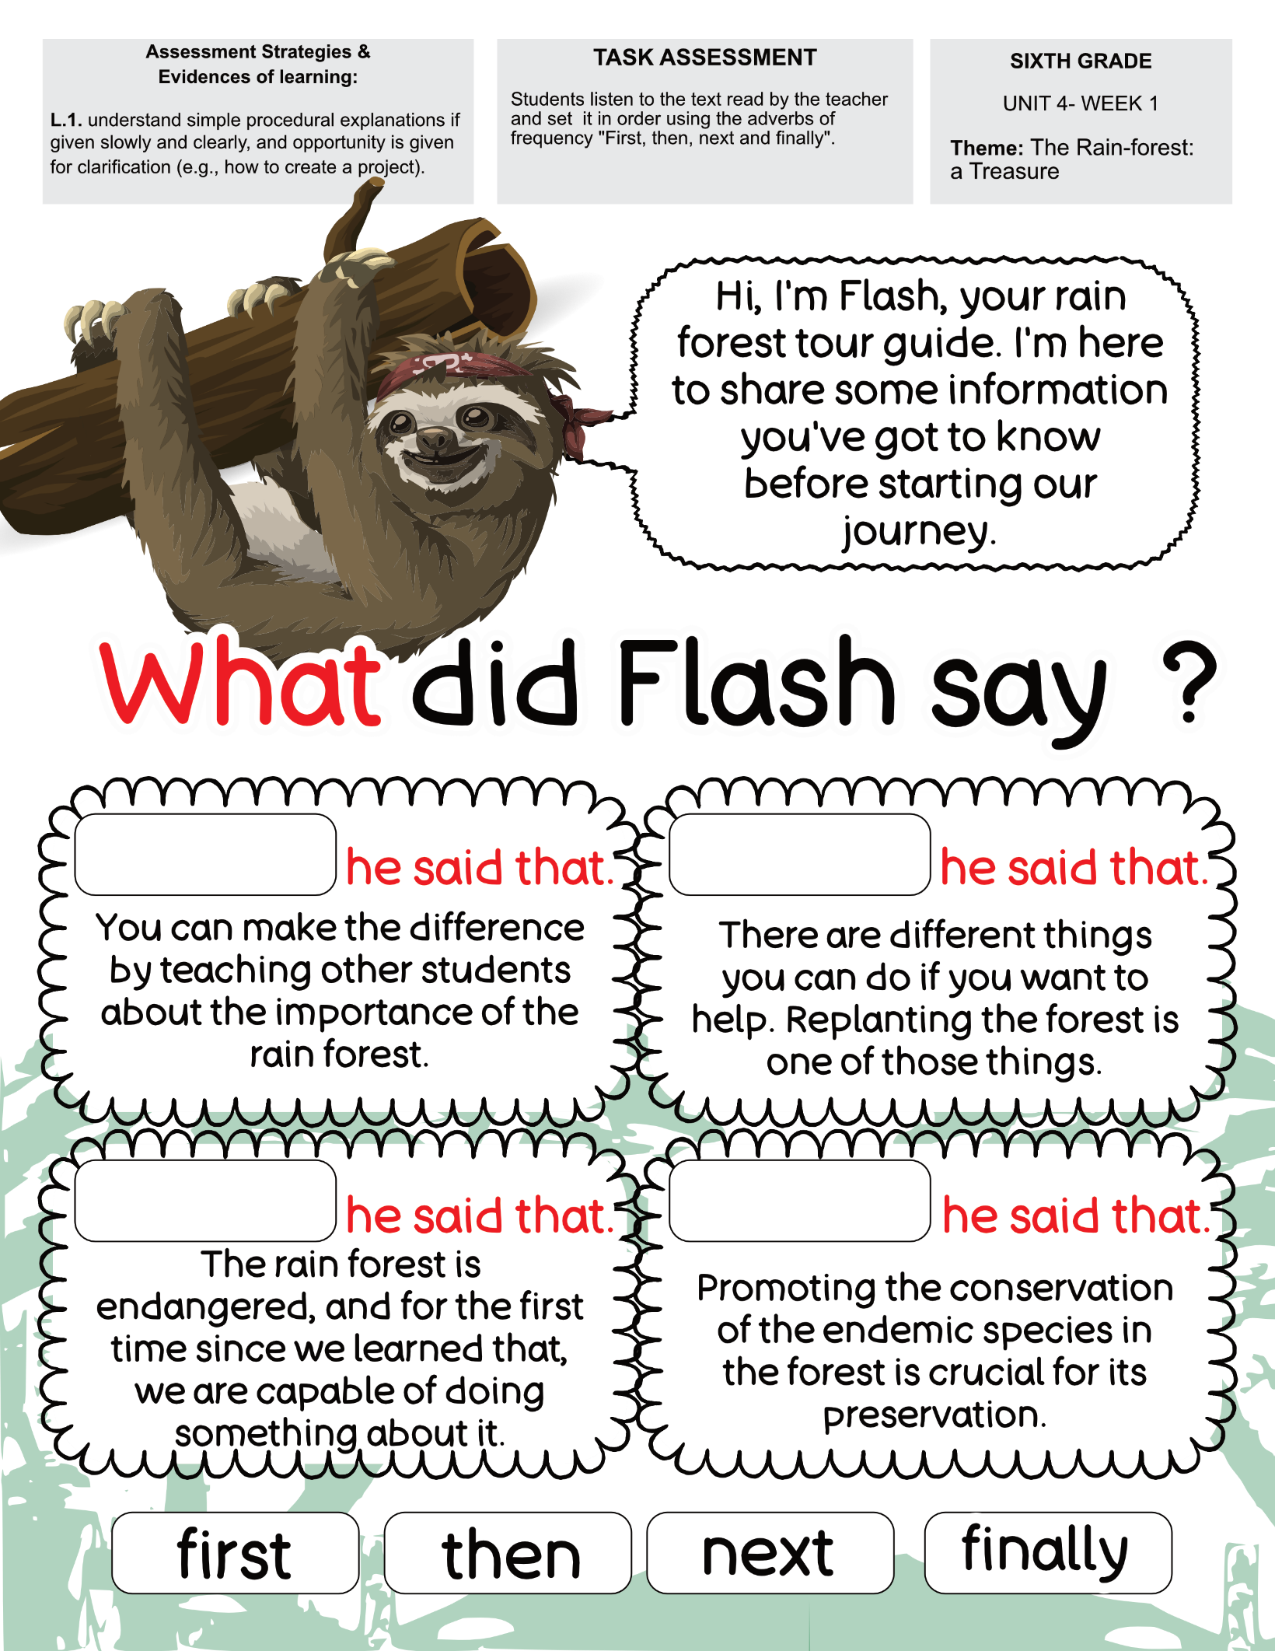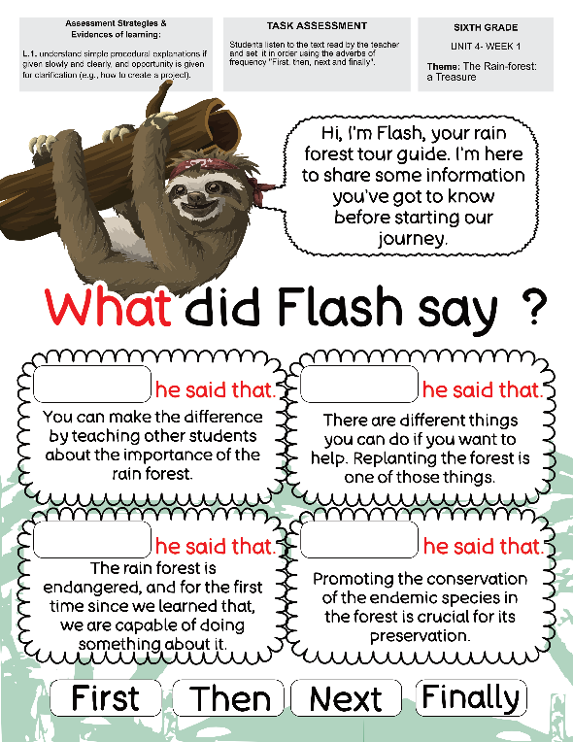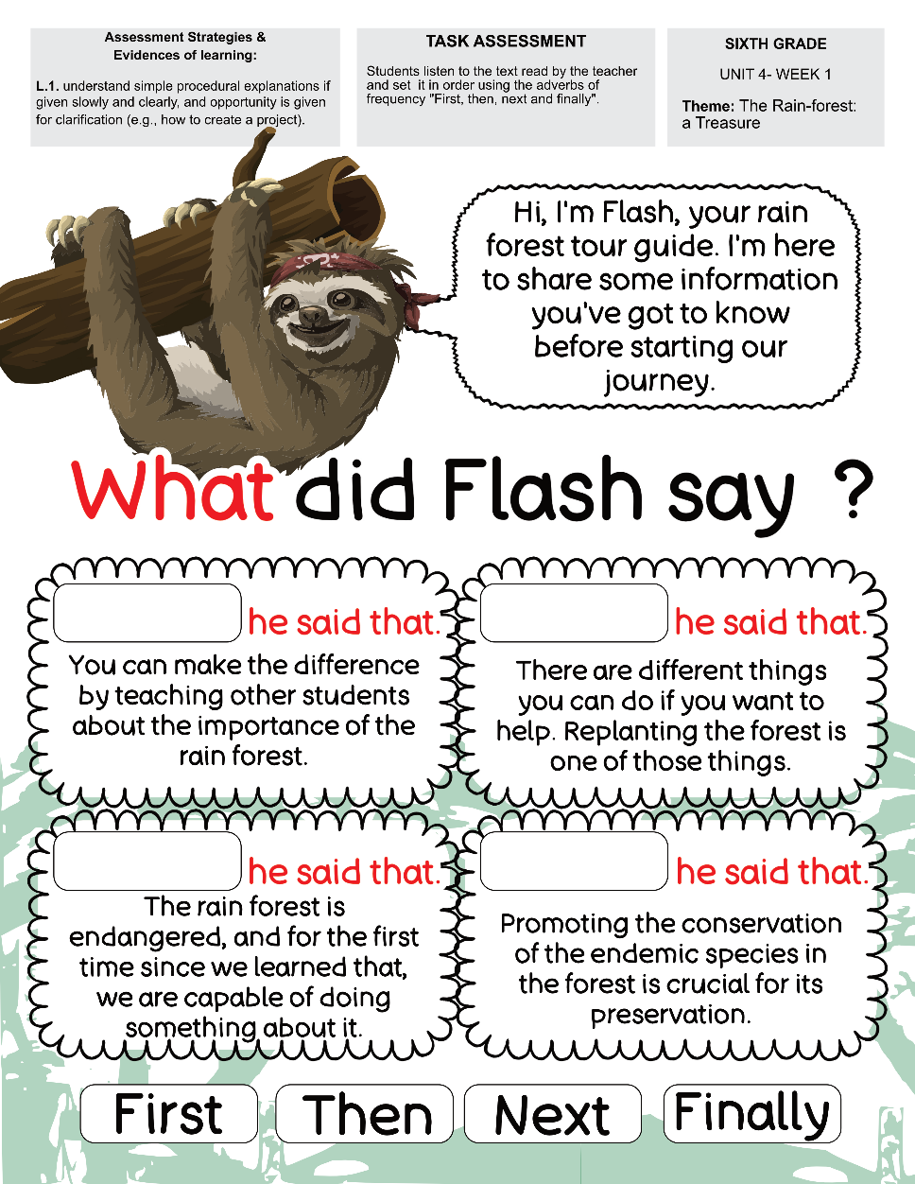Annex 6

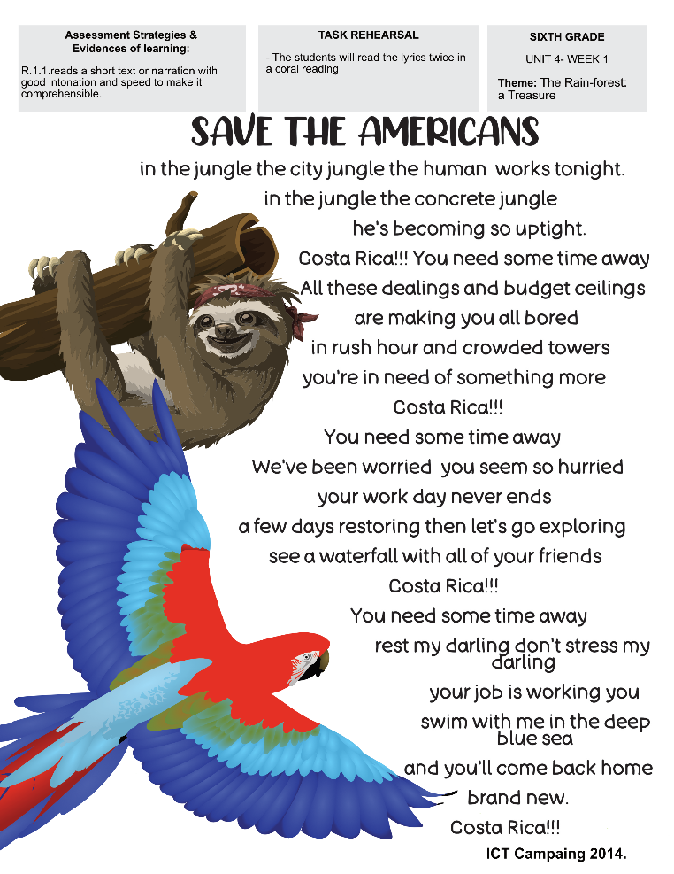Annex 7

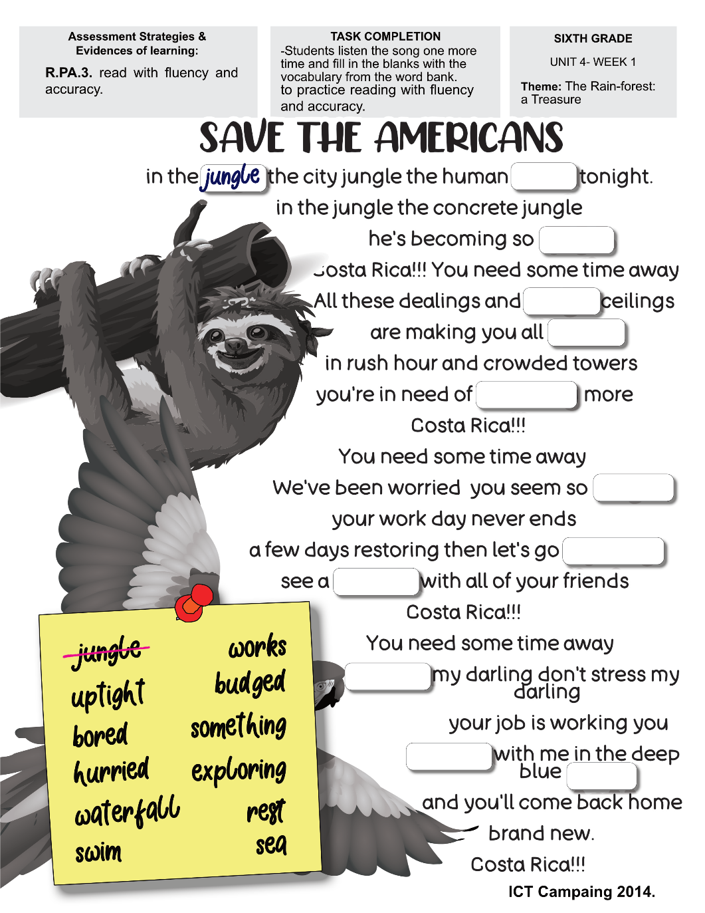Annex 8



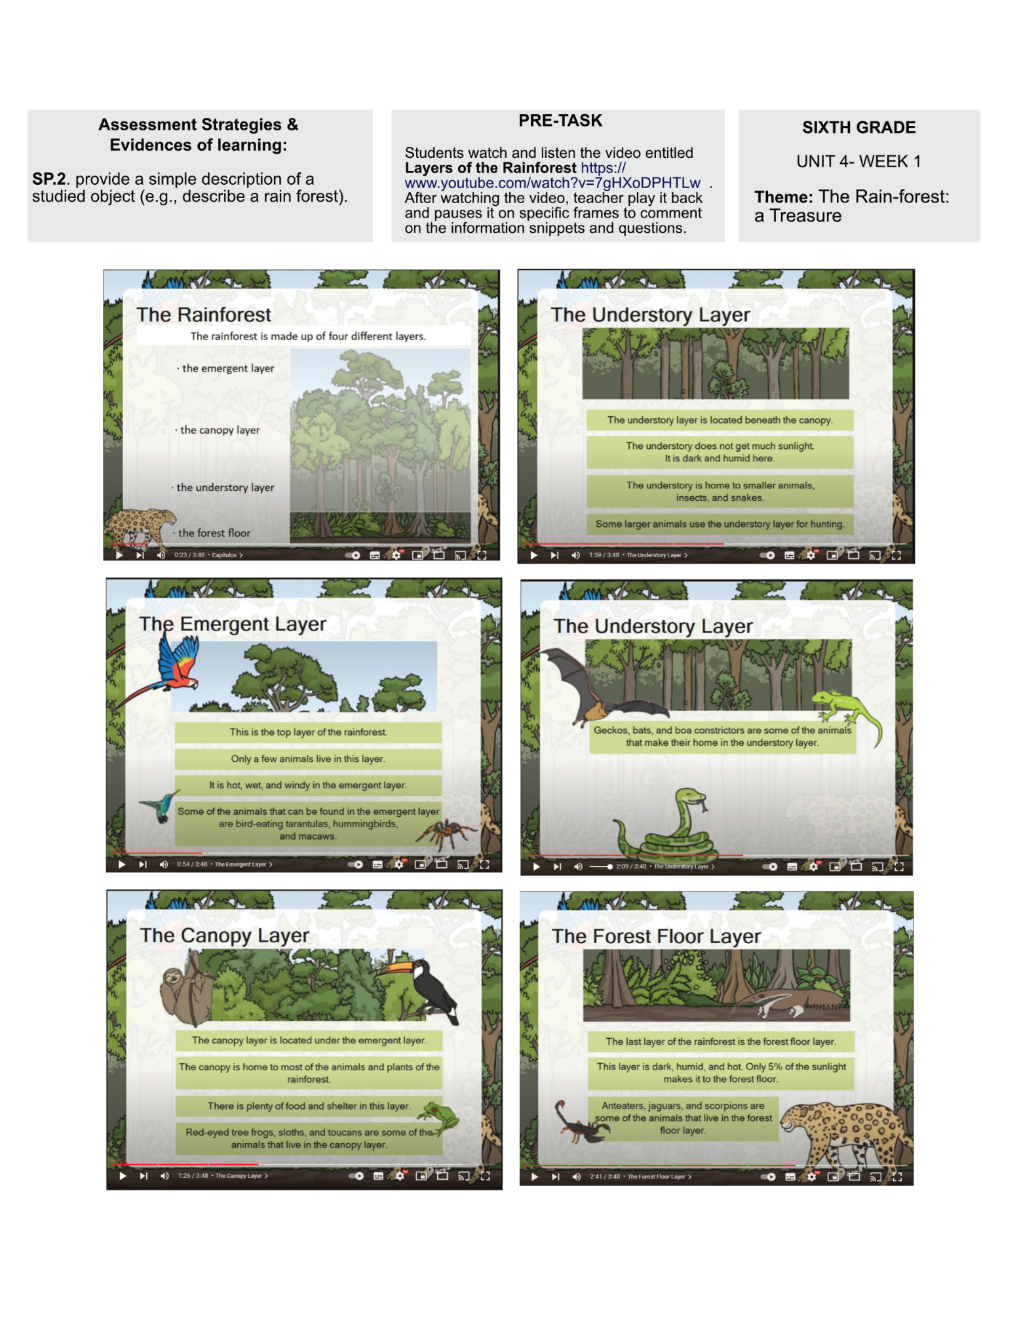Annex 9

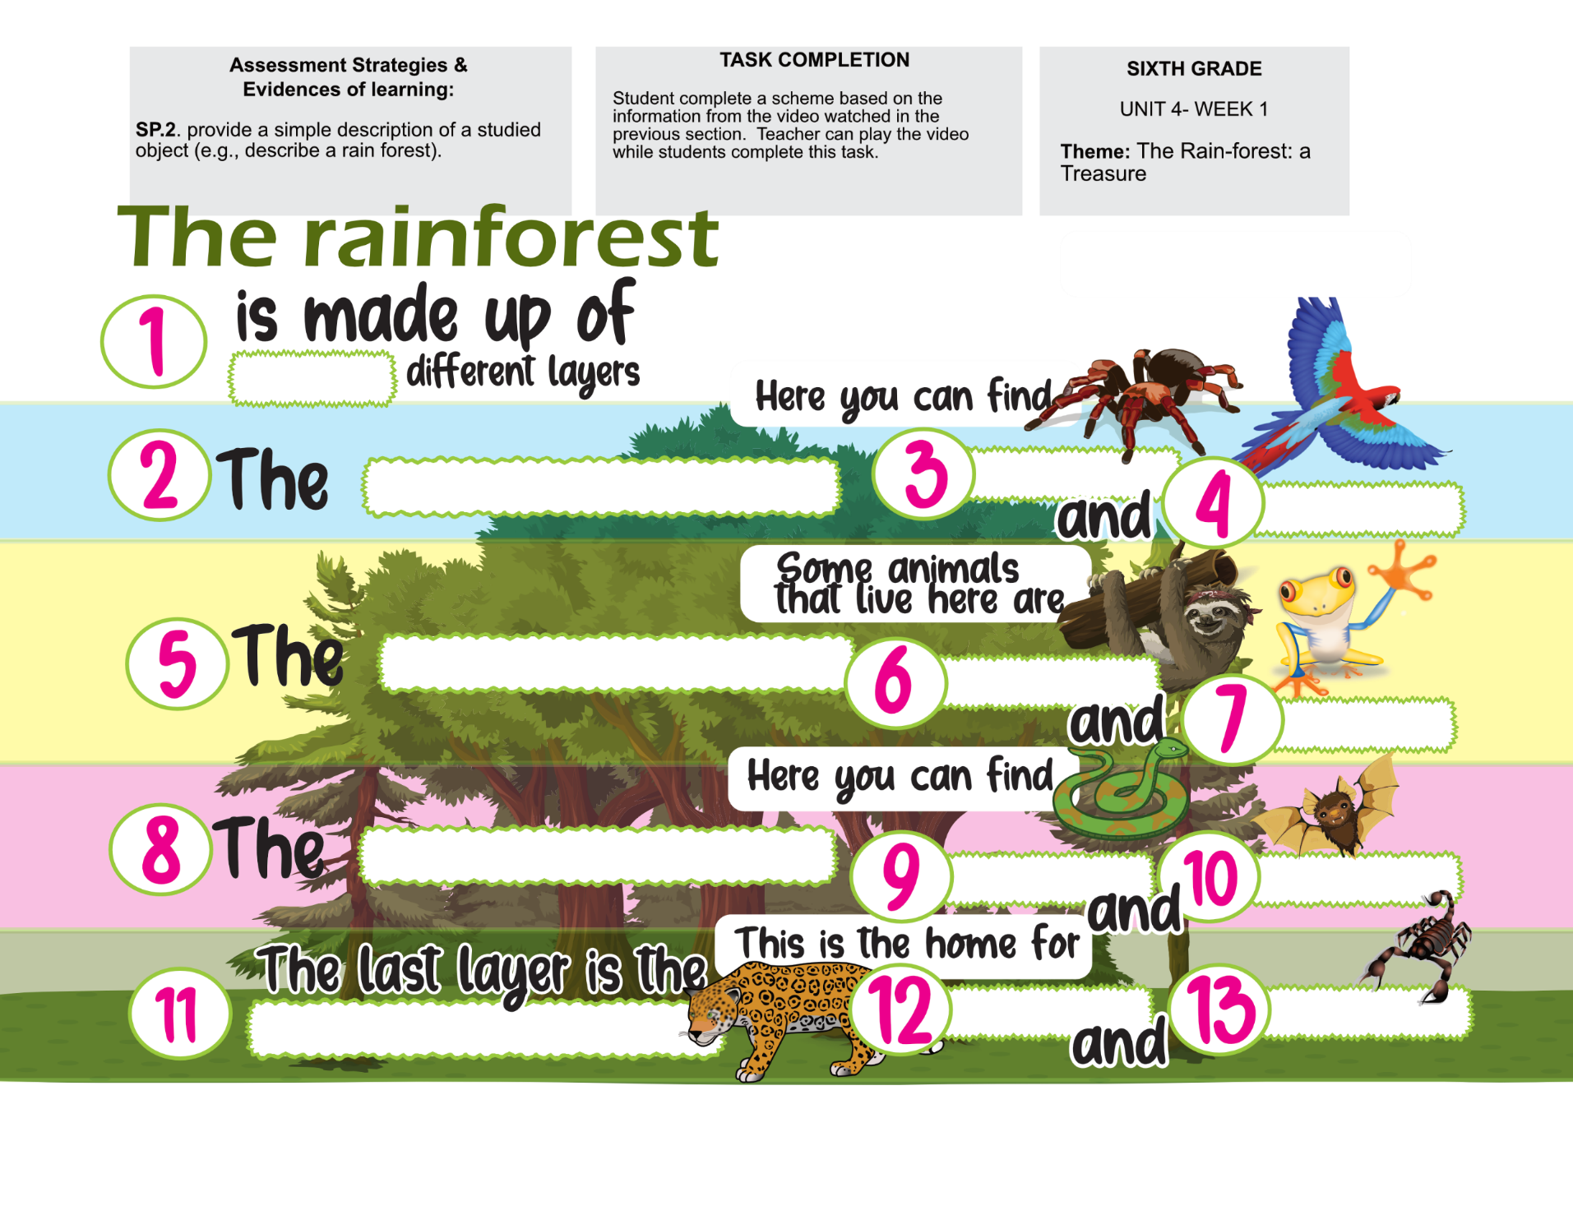Annex 10

Annex 11

**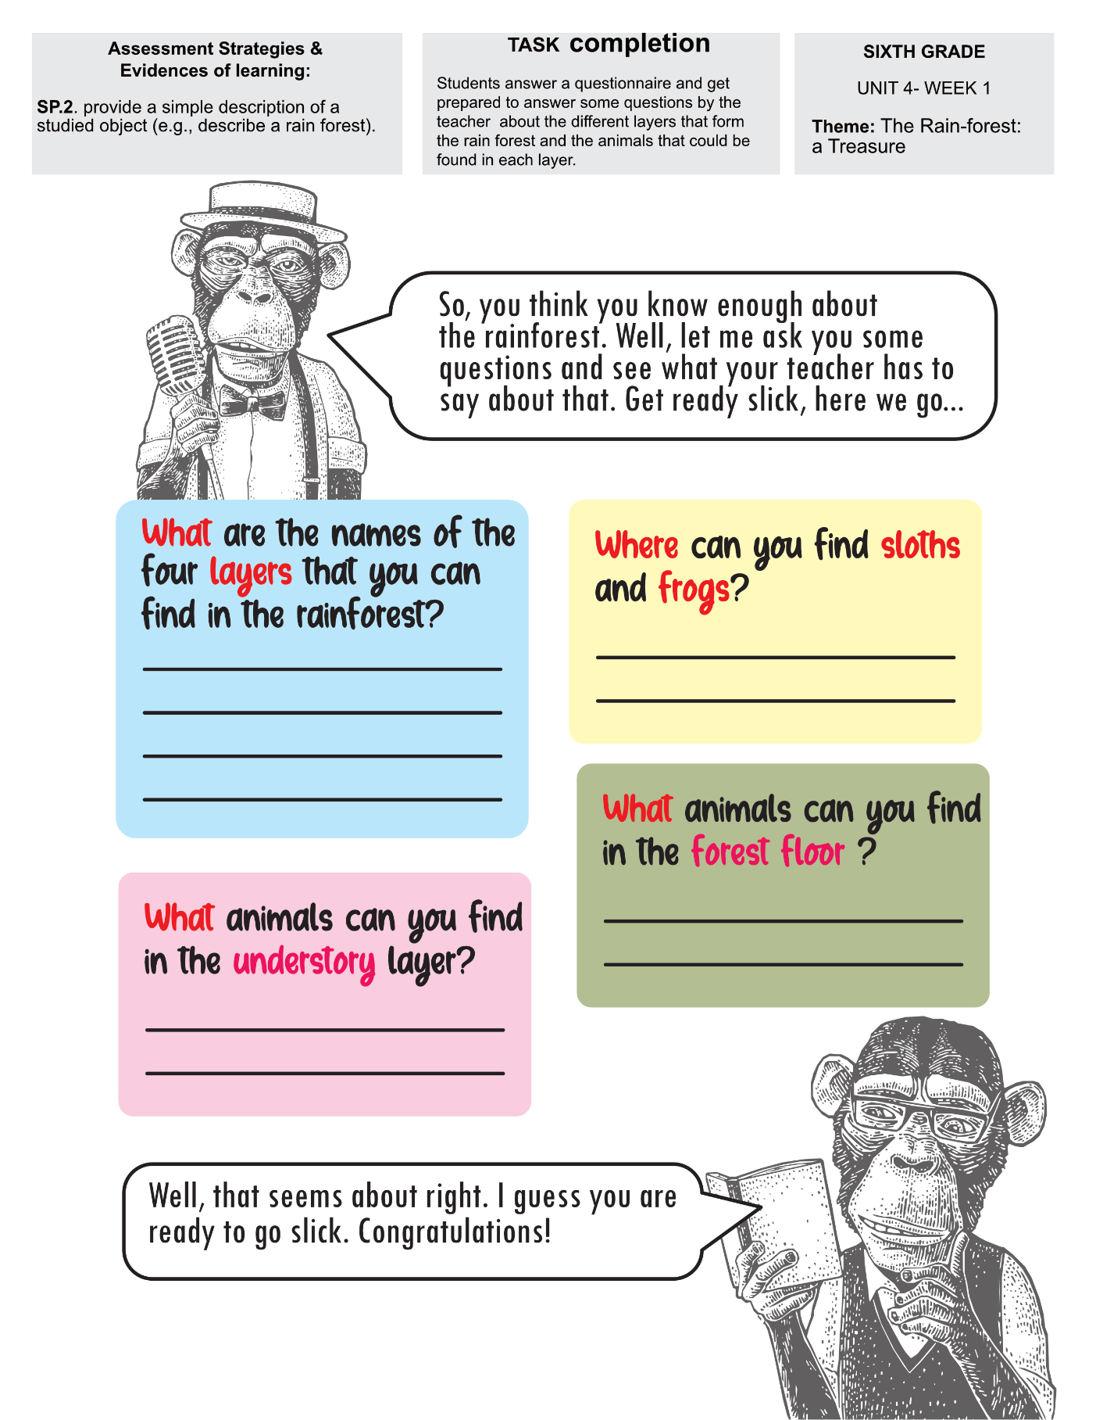**

|  |  |  |  |  |  |  |  |  |  |
| --- | --- | --- | --- | --- | --- | --- | --- | --- | --- |
| **Term: 2** | | **Level: Fifth Grade** | | | **Unit: 4** | | | **Week:2** | |
| **Domain: Socio-interpersonal** | | | | **Scenario: Rainforest Rescue** | | **Theme:** Are We Saying “Goodbye” to the Rainforest? | | | |
| **Enduring Understanding**: Rainforests are tall, densely growing, broad-leaved evergreen trees in a tropical area with high annual rainfall. They recycle and clean water; protect against pollution and erosion, provide plants for food and medicine provide homes for many types of life forms. Rainforests are quickly being cut down mostly for wood to build houses and roads as well as making space for cattle raising and farming. | | | | | | | | | |
| **Essential Question:** What are rainforests and what happens if they disappear? | | | | | | | | | |
| **Dimensions**  **1. Ways of thinking ( )**  **2. Ways of living in the world ( )**  **3. Ways of relating with others ( )**  **4. Tools for integrating with the world ( )** | | | | | | | | | |
| **Learn to Know** | | | | **Learn to Do** | | **Learn to Be and Live in Community** | | | |
| **Grammar & Sentence Frames**  Adjectives (different types)   * Some trees live for a hundred years. * Huge trees live in a rainforest. * You see that little light gets across the canopy. * Some trees drop their leaves.   Wh information  questions in present  tense   * Why are rainforests important? * What can we do to rescue the rainforest? * What causes harm to the rainforest?   Simple present using (S+V+PP) pattern   * Different species live in the rain forest. * Ferns grow in the rainforest. * Rainforests are in different parts of the country.   **Phonemic Awareness**  Sequencing event using transition words in a sentence frame (e.g., first, next, finally).  **Vocabulary**  **2.** Are we saying “Goodbye” to the Rainforest?  Threats (nouns)   * Urbanization * Deforestation * Irresponsible tourism * Road construction * Hunting * Pollution * Wildfires   Verb forms   * Cut down * Damage * Destroy * Build * Cause | | | | **Function**   * Describing the condition of the rainforests   **Discourse Markers**  Linkers: Sequence adverbs-past tense  First, next, then, finally | | **Psycho-social**   * Discriminating between instrumental and integrative reasons to rescue the rainforest (personal benefit vs. community benefit)   **Sociocultural**   * Sharing experiences and concerns about the rainforest current situation   **Idioms/ phrases**   * Take care of the earth and she will take care of you. | | | |
| **Assessment Strategies & Evidences of learning**  (Diagnostic, formative, summative) | **Goals** | | | **Pedagogical Mediation/ Didactic Sequence** | | | | | **Time** |
| Learner… | Learner can | | | **Pre-teaching**  Routine: Checking attendance, checking in with Ls, T posts the Essential Question and Enduring Understanding and talks with the students about both of them. T shares the class agenda, etc. on the board  **Warm up**  The teacher will paste some flashcards on the whiteboard, related to the vocabulary, and the class will be divided on 3 groups. Each group will take turns to say as many words as they know or recognize as a game. They have to respect each other’s answers. The teacher will copy their answers on the whiteboard. Some of them are: rainfall, climate, flora and fauna, canopy, species, warm, dense, exotic, tropical, dark (Annex 1)  A series of pictures that represent:  rainfall, climate, flora and fauna, canopy, species, warm, dense, exotic, tropical, dark.Serie de ilustraciones que representan una serie de palabras a estudiar.  **Activation of Prior Knowledge** In the following link, you will find a video about the importance of rainforests: https://www.youtube.com/watch?v=zV2druTpnaA The teacher will tell the students to pay attention to the different animals they can recognize and write their names in their notebooks. Then, they will share them with the rest of the class. The teacher will write down the answers on the whiteboard, and the students will check their own answers. **Modeling**  By taking turns, every person in the classroom will choose an animal and with the help of the teacher, they will write a sentence describing places and things they saw on the video in order. For example; First, I saw a rainforest. Next, we saw a gorilla hanging from a tree. Then, the boy saw a toucan in a tree. Finally, a person is picking up the plastic bags from the grass…  **Clarifying**  Students will talk to each other about the Costa Rican rainforest, the flora and fauna we can find in it, and their importance. | | | | | 40 minutes |
| **L.2.** Recognizes the general idea of overheard conversations.  **L.2.1.** identifies the general idea of overheard conversations related with the rainforest.  **L2.2** recognizes the general idea of overheard conversations related with the rainforest. | **L.2.** comprehend the general idea of overheard conversations. | | | **Pre-task**  Students will listen to a conversation related to the importance of the rainforests to be able to recognize some ideas and vocabulary from it. The teacher asks students to identify familiar words and phrases.   |  |  | | --- | --- | | Maria: | Hi, Pedro. I went to Arenal National Park last Saturday. | | Pedro: | Hi, Maria. Really, how was it? | | Maria: | It is a very nice place. Do you know it is a Rainforest? | | Pedro: | No, I did not that… What is a Rainforest? | | Maria: | Rainforests are in different parts of the country, Arenal Volcano is one of them. Mr. González, my teacher, told us that more than two thirds of the world’s plant species live in rainforest environments. That’s more than 80,000 different plants! | | Pedro: | Oh, that is interesting… so different species live in the rain forest… | | Maria: | Yes… And also you can see lots of monkeys and hummingbirds and lots of other species. | | Pedro: | I will tell my family to visit the National Park… | | Maria: | Do it. Rainforests are very important. See you later | | Pedro: | Bye. |   In the following link, you will find the online audio with the conversation <https://youtu.be/8HTcGFMFg9k> The teacher can also read it with the help of a hand puppet if he/she does not have internet connection.  After listening to the conversation, students participate sharing the words and phrases that are familiar.  **Task-rehearsal**  The teacher will copy on the board the following ideas:  Rainforests are not necessary for the world.  Rainforests are very important.  You can find a lot of animals in the rainforest.  There are not animals on the rainforest.  Then the teacher will explain to the students that they will listen to the previous conversation for a second time and they will identify the general idea by completing a mind map, they can use the structures given and copied by the teacher on the board. (Annex 2)  Students get in trios and share their answers. They talk and decide if they want to change their answer.  **Task completion**  **Task**: At school, you are preparing an excursion to a rainforest. A friend of yours does not know what a rainforest is, so you are going to listen to the conversation to get the general idea and talk to your friend about the school excursion and what the rainforest is.  Working in a different trio, the students will listen to the conversation again. Every student will confirm or change their answer.  Then, they will share their mind maps, and talk about the correct general idea with their classmates trying to give reasons for their choice.  The teacher reads one option from the board at a time and will ask students to raise their hand according to the option they chose. When the teacher has asked about every option on the board, (and depending on the students answers) the teacher will ask questions to help students recognize the general idea.  **Task assessment**  Every group will share their general idea related to the rainforest with the rest of the class. The teacher will encourage critical thinking among the students by asking every group to share their reasons for their choice.  **Option 2.** Get in pairs and pretend your friend does not know what a rainforest is. Tell him/her about the excursion and what a rainforest is. | | | | | 40 minutes |
| **R.PA.3.** Reads with fluency and accuracy.  **R.1.2.** reads words and sentences related with the rainforest and its preservation with good pronunciation and with attention to punctuation pauses.  **R.1.3.** reads with accuracy and fluency a short text related with the rainforest and its preservation to support comprehension of listener. | **R.PA.3.** read with fluency and accuracy | | | **Pre-task**  The teacher will copy the new vocabulary on the board, for example: instead, two thirds, gardening gloves, volunteered, Amazonian. The teacher will read them several times, then the teacher asks students to look up their meaning in a dictionary, understanding the words and pronouncing them as they write and draw them, to be able to pronounce them with fluency and accuracy.  **Option 2**. If they do not have dictionaries, the teacher can prepare a simple matching exercise with the words and their pronunciation on one side and their meaning on the other side.  **Task-rehearsal**  The class will practice a coral reading of the “Rainforest Calling”, to have more fluency and accuracy, guided by the teacher: (Annex 3)    Taken and adapted from: http://www.llanhariprimary.com/resources/home\_learning/class\_7/8th\_june/Week%202%20Comprehension%20-%20Rainforest%20Calling.pdf  **Task**: As part of the activities that you have at school with students from other countries, the teacher has asked you to read a short text about the rainforest in a civic act. Practice with a classmate, so you can read the text with fluency and good pronunciation.  In pairs, students will practice reading the text focusing on good pronunciation and attention to punctuation pauses.  **Task completion**  Students in pairs will fill in the blanks of the text studied in class, while preparing themselves to read, so they will practice their pronunciation and comprehension. The students might use the word bank from the worksheet. (Annex 4)  A handout with a fill in the blanks exercise about the rainforest.  **Task assessment**  Students, one by one, will read aloud with accuracy and fluency a paragraph of “Rainforest Calling” short text to the class. | | | | | 40 minutes |
| **SI.1.** Asks other students to confirm solutions to problems.  **SI.1.1.** Brainstorms types of questions to request others ‘people’s opinion about current situation of the rainforest and possible solutions.  **SI.1.2.** Asks other students ‘opinions about current situation of the rainforest and possible solutions. | **SI.1.** ask other students to confirm solutions to problems. | | | **Pre-task**  The teacher introduces the goal of the lesson.  The teacher will talk to the class and present to the students the following questions to request their owns’ opinions, using some flashcards (Annex 5) to help them answer properly:   * Why are rainforests important? * What causes harm to the rainforest? * What can we do to rescue the rainforest?   **Solutions to problems in a rainforest. They produce oxygen. Replant the forest. Illegal hunting. Educate the new generations among others.**  **Task-rehearsal**  The class will talk about the rainforest and the nowadays problems to motivate the students to brainstorm two or three questions and possible solutions. Students write down their questions in their notebooks.  The teacher shares the task with the students. **Task**: You and your friend are at a rainforest in Costa Rica. You are worried because you see some problems. Talk to your friend about the situation of the rainforest and possible solutions.  Students sit down in pairs and practice asking and answering the questions that they have.  **Task completion**  The class will work in pairs, so they can ask and answer questions about their opinions by filling up the chart, Annex 6 to remember the different answers.  **A handout with questions about the current situation of the rainforest and possible solutions by filling up a chart.**  **Task assessment**  Some groups will present their opinions to the rest of the class. | | | | | 40 minutes |
| **W.2.** Devises a timeline for a topic.  **W.2.1.** Lists the most important topics in a text.  **W.2.2.** Arranges the topics in a logical sequence. | **W.2.** devise a timeline for a topic. | | | **Pre-task**  The teacher will paste some flashcards on the whiteboard about the vocabulary, for example an empty land, a mountain burning, a rainforest, some seeds, among others, and she/he will ask the students to tell her/him which of the pictures could be the beginning of a rainforest… (Annex 7) and to order the rest of the pictures in the order that they believe corresponds. The teacher will write a number under each picture (first, second, and so on), When all of the pictures are numbered, the teacher explains to the students that it is an example of a timeline for a rainforest. Students will repeat the timeline after her.  **Task-rehearsal**  **T**he students listen and read a text about the importance of Tropical Rainforest. Adapted from: https://kids.britannica.com/kids/article/rainforest/353695    The teacher shares the following task with the students: **Task**: A classmate was absent this day at school. You and a friend will make a list of the most important topics about a text that the teacher shared with you today to share with your absent friend.  The class will talk about the reading and the topics that they think are in the reading.  Then; in pairs, students will make a written list of the most important topics of the text.  The teacher asks volunteers to go to the whiteboard and write down the topics. This does not have to be done in any particular order. The teacher will check that all important topics are there. Students self-evaluate their answers.  **Task completion**  Then, they will arrange the topics from the list they did in a logical sequence in a time line.  **Task assessment**  Students will present their time lines to the class. | | | | | 40 minutes |
| **Integrated Mini-Project** | | | | | | | | | **Time** |
| Phase: \_2\_\_\_\_\_\_  The students will work on their groups making:   1. A list of the ideas of the important topics they want to talk. 2. Drafting the sentences for their presentation.   You as teacher can give them ideas and guide them while giving feedback to the groups. | | | | | | | | | 40 minutes |
| **Reflective Teaching** | | | | | | | | | |
| What worked well | | | What didn’t work well | | | | How to improve | | |
| **Enduring Understanding Reflection** | | | | | | | | | |
|  | | | | | | | | | |

|  |  |  |  |  |
| --- | --- | --- | --- | --- |
| **Learner Self-Assessment** | | | | |
| ***I can*** | ***Resultado de imagen para happy emoji***  ***Achieved*** | ***C:\Users\mcastilloh\Downloads\Grinning-Face-with-Smiling-Eyes.png***  ***In progress*** | ***C:\Users\mcastilloh\Downloads\descarga.jpg***  ***Not achieved yet*** |
| **L.2.1.** identify the general idea of overheard conversations related with the rainforest. |  |  |  |
| **L2.2** recognize the general idea of overheard conversations related with the rainforest. |  |  |  |
| **R.1.2.** reads words and sentences related with the rainforest and its preservation with good pronunciation and with attention to punctuation pauses. |  |  |  |
| **R.1.3.** reads with accuracy and fluency a short text related with the rainforest and its preservation to support comprehension of listener. |  |  |  |
| **SI.1.1.** Brainstorms types of questions to request others ‘people’s opinion about current situation of the rainforest and possible solutions. |  |  |  |
| **SI.1.2.** Asks other students ‘opinions about current situation of the rainforest and possible solutions. |  |  |  |
| **W.2.1.** Lists the most important topics a text. |  |  |  |
| **W.2.2.** Arranges the topics in a logical sequence. |  |  |  |

Annex 1

|  |  |
| --- | --- |
| * Rainfall   Picture of two people walking in the rain.  <https://ggwash.org/images/posts/_resized/42915090990_21fd8df572_k.jpg> | * Climate   A group of pictures representing the climate.  https://digitalprojects.davidson.edu/earthday2020/wp-content/uploads/2020/04/stakeholder-3-2.png |
| * Rainy * A person with an umbrella under the rain.   <https://3.bp.blogspot.com/-XEBfGqYKGT0/XHHSj1j9WFI/AAAAAAAAk1k/RFtmy4L3hIEDcMixIjeo0z_a4btiAIZigCLcBGAs/s1600/Rainy%2BNight1.png> | * Cloudy * A picture of some clouds and tops of trees.   https://images.pexels.com/photos/1818/sky-clouds-cloudy-forest.jpg?cs=srgb&dl=sky-clouds-cloudy-forest-1818.jpg&fm=jpg |
| * Flora and fauna   A picture of a sloth hanging from a tree.  https://www.youtube.com/watch?v=QbhCpfxsod8 | * Canopy   A picture of a person in a canopy.  https://www.google.com/url?sa=i&url=https%3A%2F%2Fwww.arenalcanopy.com%2Farenal-canopy-espa%25C3%25B1ol%2Farenal-mundo-ventura%2F&psig=AOvVaw1BKGXyZjBiHWCfRkf8n61t&ust=1653147140427000&source=images&cd=vfe&ved=2ahUKEwjw2-aRs-73AhXyYjABHZq1CwsQr4kDegUIARDCAQ |
| * Species * Three pictures in one of a sloth, jaguar and a toucan. * https://blog.amstardmc.com/discover-diverse-animals-of-costa-rica/ | * Warm A dog sleeping under some fabric.   https://cdn.northstarmoving.com/blog/wp-content/uploads/2012/12/4101098092\_6659ed07b2\_z.jpg |
| * Dense * A picture of some nature growing around trees.   <https://www.publicdomainpictures.net/pictures/220000/velka/dense-creeper-covering-trees.jpg> | * Dark * A picture of the moon and some dark trees under it.   https://orig00.deviantart.net/6437/f/2012/319/b/f/dark\_forest\_by\_kgbistas-d5l2cq5.jpg |
| * Tropical * A picture of some palm trees at the beach.   <https://www.weekendnotes.com/im/009/03/mustsee-attractions-in-tropical-north-queensland-a1.jpg> |  |

Annex 2

Annex 3

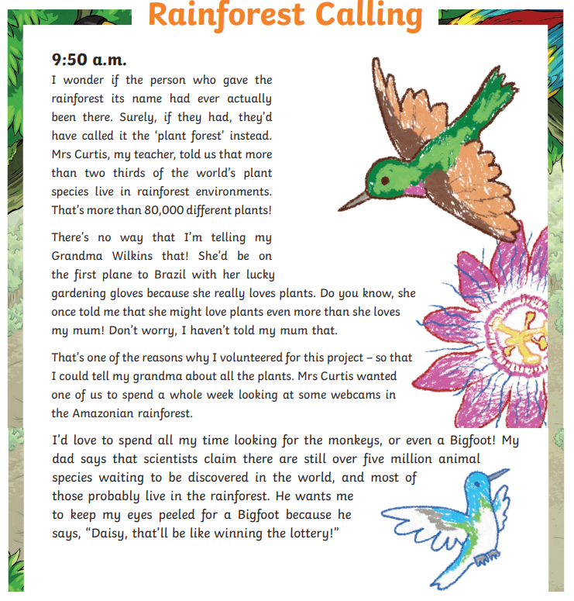

Annex 4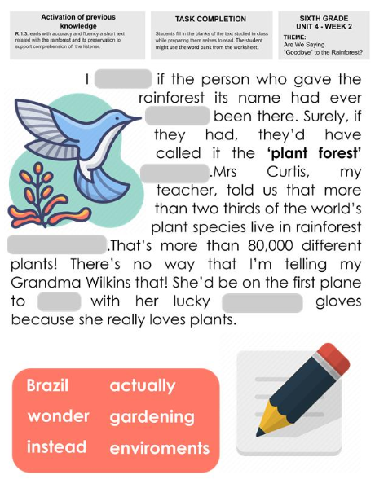

Annex 5

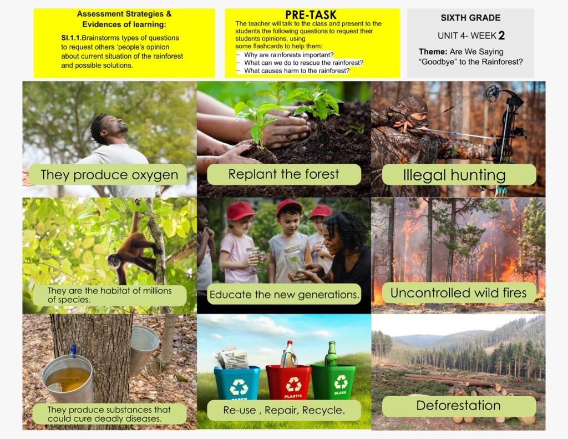

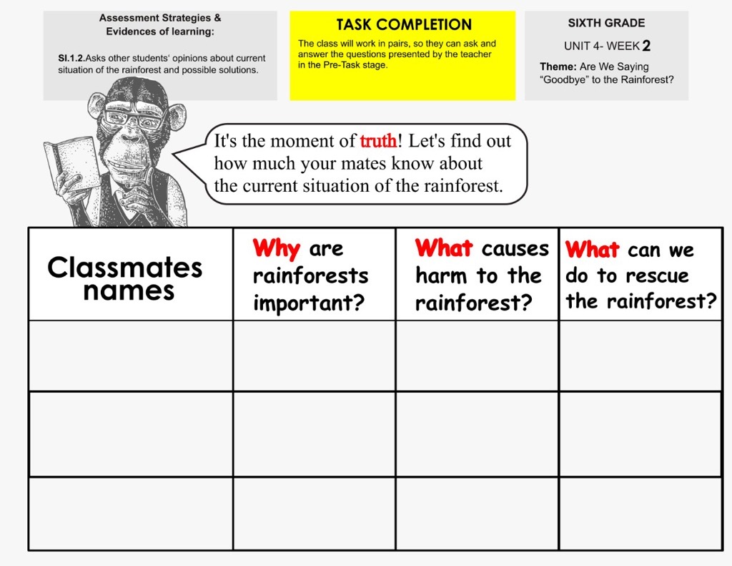Annex 6

Annex 7 Flashcards

**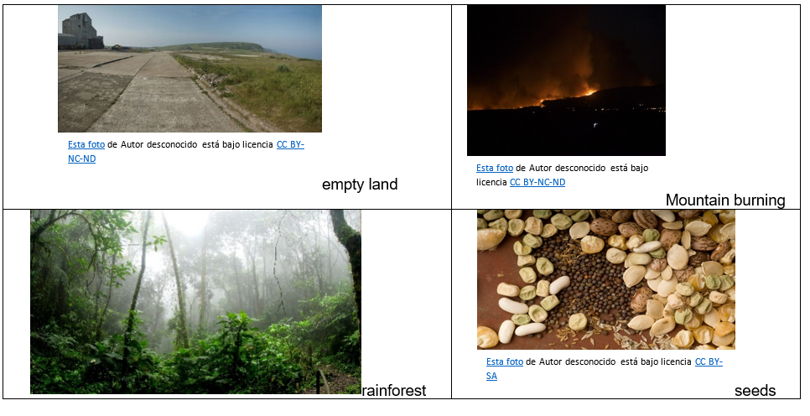**

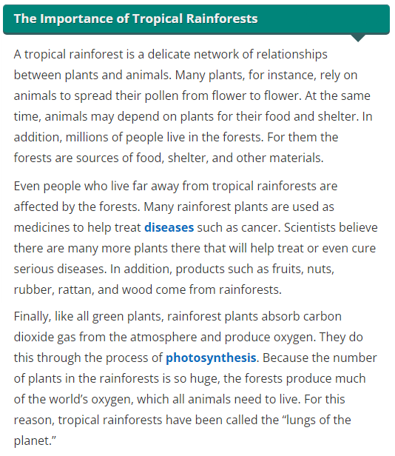

|  |  |  |  |  |  |  |  |  |  |
| --- | --- | --- | --- | --- | --- | --- | --- | --- | --- |
| **Term: 2** | | **Level: Fifth Grade** | | | **Unit: 4** | | | **Week:3** | |
| **Domain: Socio-interpersonal** | | | | **Scenario: Rainforest Rescue** | | **Theme:** Ways to Rescue It | | | |
| **Enduring Understanding**: Rainforests are tall, densely growing, broad-leaved evergreen trees in a tropical area with high annual rainfall. They recycle and clean water; protect against pollution and erosion, provide plants for food and medicine provide homes for many types of life forms. Rainforests are quickly being cut down mostly for wood to build houses and roads as well as making space for cattle raising and farming. | | | | | | | | | |
| **Essential Question:** What are rainforests and what happens if they disappear? | | | | | | | | | |
| |  | | --- | | **Dimensions** | | **1.** **Ways of thinking (   )** | | **2. Ways of living in the world  ( )** | | **3. Ways of relating with others  ( )** | | **4. Tools for integrating with the world  ( )** | | | | | | | | | | |
| **Learn to Know** | | | | **Learn to Do** | | **Learn to Be and Live in Community** | | | |
| **Grammar & Sentence Frames**  Comparative and superlative forms   * Eating food grown in a sustainable way is (good, better, best) for the rainforest. * Learning about the rainforest is (good, better, best) for students. * Using palm oil is (bad, worse, worst) for the rainforest.   **Phonemic Awareness**  Practicing minimal pair sounds**: v / b**  **vote / boat**  **very / berry**  **van / ban**  **vest / best**  **vet / bet**  **vat/bat**  **Vocabulary**   * Ways to Rescue It   Verb forms   * Protect * Value * Educate * Plant * Save * Use   Adjectives   * Endangered * Sustainable * Less   Nouns   * Biodiversity * Landscape * Wildlife * Paper | | | | **Function**   * Describing cause effect relationships   **Discourse Markers**  Linkers: Sequence adverbs-past tense  First, next, then, finally | | **Psycho-social**   * Discriminating between instrumental and integrative reasons to rescue the rainforest (personal benefit vs. community benefit) * Expressing ethical and moral values when making decisions related to rainforest preservation   **Sociocultural**   * Sharing experiences and concerns about the rainforest current situation * Using expressions of belief via graffiti, t-shirt slogans and catch phrases   **Idioms/ phrases**   * Show your care, do your share   Save the planet. | | | |
| **Assessment Strategies & Evidences of learning**  (Diagnostic, formative, summative) | **Goals** | | | **Pedagogical Mediation/ Didactic Sequence** | | | | | **Time** |
| Learner… | Learner can | | | **Pre-teaching**  **Routine**: Checking attendance, checking in with Ls, T posts the Essential Question and Enduring Understanding and talks with the students about both of them. T shares the class agenda, etc. on the board.  **Warm up**  In the following link, you will find a video that students will watch: Deforestation 2-d animation, <https://www.youtube.com/watch?v=9E4j6jphTaU>.  Then they will brainstorm the principal ideas of the video, the teacher will copy them on the board.  **Activation of Prior Knowledge**  The class will have a walk through the green zones of the school, the students will draw attention to the beauty-blue skies, leaves… Teach the students about the different plants you can find there, the trees or the animals they can see.  Promote conversations about protecting them, value their importance, saving and using them in a reasonable way… like natural medicines or teas.  Back indoors, the teacher will present the students some sentences for them to use the comparative and superlative forms, for example: Eating food grown in a sustainable way is (good, better, best) for the rainforest.  Learning about the rainforest is (good, better, best) for students.  Using palm oil is (bad, worse, worst) for the rainforest.  **Modeling**  Teacher will show the students a chart, and she will paste it on the board. The students will brainstorm words of things or animals they know that could be categorized under each category of the chart as it corresponds, and the teacher will write them down. (Annex1)  Endangered taken from https://webenglish.se/wp-content/uploads/2020/08/List-Of-Endangered-Animals-1.jpg  Sustainable taken from https://www.onecommunityglobal.org/wp-content/uploads/2021/03/410-BUILDING-OPEN-SOURCE-SUSTAINABLE-CITIES-1197X627.jpg  Less taken from bing search  As students finish their brainstorm, the teacher will guide them about how to categorize the animals and things. The teacher provides some examples: the endangered animals can be explained just as endangered wildlife… use less paper …sustainable biodiversity … sustainable landscape…  **Clarifying**  The class will stand up and they will play “hot potato”. The teacher will point to one of the words of the chart and the student that got the ball will say a sentence with the adjective as it corresponds… for example, we use less paper… Cut less trees… among others. | | | | | 40 minutes |
| **L.1** Recognizes simple procedural explanations if given slowly and clearly.  **L1.1.** identifies simple procedural explanations about the rainforest if delivered slowly and clearly.  **L1.2** recognizes simple procedural explanations about the rainforest if delivered slowly and clearly. | **L.1** Recognize simple procedural explanations if given slowly and clearly. | | | **Pre-task**  The teacher introduces the goal of the lesson.  The class will play “tell me a story about the rainforest” the teacher explains to the class that we are going to make up a story by using the following words at the beginning of the sentence each time they are going to change an idea (teacher writes the words on the board: procedural explanations) So the teacher starts by saying: First, I went to the rainforest in “Parque del Agua” with my family…and students will continue.  First,  Next,  Then,  Finally  **Task-rehearsal**  Students will listen to the teacher’s script, teacher will tell the students to listen carefully and take notes of the procedural explanation they are listening to.  **Four Basic Steps for Saving the Rainforests**  **First,** teach others about the importance of the environment and how they can help save the rainforests.  **Next,** restore damaged ecosystems by planting trees on land where forests have been cut down.  **Then,** encourage people to live in a way that doesn't hurt the environment.  **Finally,** supportparks and companies that minimize damage to the environment and protect the rainforest and the wildlife.  Text adapted from: https://rainforests.mongabay.com/10-how-to-save-rainforests.html  Students will share with the class what they identified.  **Task completion**  Students will listen to the teacher again and will recognize simple procedural explanations in the piece heard by ordering the sentences following the correct steps and matching them with a line. Students work on the worksheet (Annex 1 and Annex 2).  Task completion  Recognize the simple procedural explanations by ordering the sentences by matching them with a line.  The class will check the activity all together.  **Task assessment**  Students will make a draw concerning their favorite part of the information heard**.** | | | | | 40 minutes |
| **R.PA.4.** Distinguishes between sounds /v / b/ in words.  **RPA.1.1**. identifies words with the sounds /v / b/ in words.  **RPA.1.2**. Compares similarities and differences between the sounds /b/ and /v/ when heard in words.  **RP.A.1.3**. pronounces sounds /v/ and /b/ in words. | **R.PA. 4.** demonstrate knowledge of phonemic awareness. | | | **Pre-task**  The teacher introduces the goal of the lesson. In the following link, you will find a video that students will watch/ listen: [b] vs. [v] | English Pronunciation Lesson, <https://www.youtube.com/watch?v=Ghb6qapA_gM>.  Students will pay attention to the part about how they place their mouth when they have to pronounce each sound.  How to place your mouth, lips and teeth when you pronounce the sounds V / B  **Task-rehearsal**  The teacher writes a list of words related to the week’s theme on the board or uses the flashcards (vote / boat, very / berry, van / ban, vest / best, vet / bet, vat/bat. Then, the learners, along with the teacher, read each word and write it in the air, paying attention to how the sound is produced in the vocal cords and the sensations that it causes, for example, vibration. (Annex 4)  A flashcards with the words and pictures: Vote / boat very / berry Vest / best Vat / bat Vet / bet Van / ban  **Task completion**  The teacher shows a set of letters to the students and explains to them that those letters are the first letters of the words they just reviewed. (Please, erase the words from the board.)  Students complete the words by writing their first letter /v/ or /b/. They use the images as a visual aid. (Annex 5)  A workseet with words for the students to identify wich one is with /V/ and witch one starts with /b/ ____est ____ote ____ at ____erry ____et ____at ____est ____oat  Students will talk in pairs about the similarities and differences they can find between the sounds /b/ and /v/ when heard in words, and when they write them too. They will write down the differences they found and share it with the rest of the class.  Students will pronounce them by practicing orally the minimal pair sounds**: v / b**  **vote / boat**  **very / berry**  **van / ban**  **vest / best**  **vet / bet**  **vat/bat**  **Task assessment**  Students will play “I know the word”. They will work in pairs. Teacher will show the students the flashcard. One of the pair members will pronounce the word in a correct way, and the other member will say if the sound heard at the beginning of the word is V or B. Then they will identify one similarity or difference between the two letters, for example:  Vote Boat  Student A: Vote / Student B: V: you place your front teeth on the lower lip and it vibrates**.** | | | | | 40 minutes |
| **SP.1.** Describes, using simple words, their opinion of a situation or event.  **SP.1.1**. brainstorms ideas related to ways to rescue the rainforest.  **SP. 1.2.**outlines with simple phrases and sentences personal opinion about ways to rescue the rainforest.  **SP.1.3.** describes with simple words,phrases and sentences personal opinion about ways to rescue the rainforest in a presentation. | **SP.1.** describe, using simple words, their opinion of a situation or event. | | | **Pre-task**  The teacher introduces the goal of the lesson.  In the following link, you will find a video: **“Anthem for the Amazon”** <https://www.youtube.com/watch?v=ZKumZJPClec>  The students watch and listen to the song. They express one idea about what they think is the message of the song. They teacher writes their ideas on the board.  Then, students will share their experiences and concerns about the rainforest current situation, the teacher will guide them in the discussion by asking them questions like: What did you understand from the video? How did you feel? Have you been in a rainforest? Have you been to Arenal Volcano or to Río Celeste or Upala?  How can you rescue the rainforest?  Students give their ideas and the teacher will write down the ideas students express about how to rescue the rainforest on the board.  Then she explains that they will participate in the following task.    Task: Give a short speech  Topic: How to save the rainforest  Task description  You have to give a speech on a duty civic act at the school about the rainforest and you are going to explain how to save it giving at least five ideas. The speech will last 3 minutes maximum.  You will start brainstorming ideas with the help of the teacher. Then you will write your ideas in complete sentences. Next, you will support your speech presentation with pictures and rehearse it in pairs. Finally, you will be ready to give your speech.  **Task-rehearsal**  Students will write down an outline with simple phrases and sentences describing the rainforest and ways to rescue it.  In order to organize their ideas, they will brainstorm some characteristics of the rainforest and then all the possible ways to save it using a spider web.  Students in pairs, using the spider web will complete the circles with sentences that support their ideas. Additionally, they will add an introduction and a conclusion to their speech, and finally, they will rehearse it with a partner.  **Saving the Rainforest**  **Task completion**  **I**n pairs, they will edit the outline of the speech. Then, they will practice the pronunciation between each other. Students will make a visual aid, (poster) that helps them present their speech to the audience. Students will present their speech.  **Task assessment**  Students will provide feedback to their partner after the speech presentation using the following checklist.  **Peer assessment checklist/ Self-assessment checklist**   |  |  |  |  | | --- | --- | --- | --- | | I/He/ she can… | Not achieved yet | In progress | Achieved | |  |  |  |  | | 1.brainstorm ideas in oral form about ways to rescue the rainforest. |  |  |  | | 2.complete a spider web with main ideas about the rainforest and ways to save it. |  |  |  | | 3.make an outline of the speech, including an introduction, a body and a conclusion. |  |  |  | | 4.use visual aids to reinforce main ideas of the speech. |  |  |  | | 5.deliver a clear speech to an audience about how to rescue the rainforest. |  |  |  | | | | | | 40 minutes |
| **W.1.** Engages in the writing process during pre-writing, drafting, editing and simple publications.  **W.1.1.** brainstorms main ideas about ways to rescue the rainforest as a form of pre-writing.  **W.1.2.** makes an outline to organize the main ideas about ways to rescue the rainforest.  **W.1.3.** makes a draft of text by writing complete sentences for each main idea.  **W.1.4.** edits a text by checking grammar, spelling, punctuation and capitalization to make sure it is well-written. | **W.1.** Engages in the writing process during pre-writing, drafting, editing and simple publications. | | | **Pre-task**  The teacher introduces the goal of the lesson.  The teacher will explain to the class that they have to make a letter to a TDX Executive Committee about ideas and acts they as students can do to rescue the rainforest. These letters will be part of one of the TDX Talks.  The whole class will participate writing letters about ways to rescue the rainforest they will be sent to the TDX. The letter must have an introduction, a body and a conclusion. It must include a minimum of 150 word and 15 lines. Make sure to use correct grammar, spelling, capitalization and punctuation.  **Task-rehearsal**  Students will begin writing down an outline about the ideas they want to express in the letter of ways to rescue the rainforest. You can review the following video about how to write a letter: In the following link, you will find a video about how to write a friendly letter: <https://www.youtube.com/watch?v=3ClV82aT2oA>  The letter goes to the TDX Executive Committee. It must include the following:   * Introduction (Salutation) * Body * Conclusion   **Task completion**  With the outline, students will write a first draft of the letter. Once the letter is completed, in pairs they will read each other’s letters and provide feedback. They can use the following checklist.  **Peer assessment checklist**   |  |  |  |  | | --- | --- | --- | --- | | He/she can | Not achieved yet | In progress | Achieved | | The letter has an introduction, a body and a conclusion. |  |  |  | | The letter includes at least 15 lines |  |  |  | | The letter uses correct grammar. |  |  |  | | The words in the letter are correctly spelled. |  |  |  | | The letter uses correct punctuation. |  |  |  | | The letter uses correct capitalization. |  |  |  |   Based on the feedback provided, in pairs the students will edit the text of the letter to TDX Executive Committee, and will be ready to presented to the teacher for final feedback.  **Task assessment**  Some students will read and present their letter to the class. All of them will paste it on the English board. They can use the same checklist to write comments to their peers. They have to provide two positive comments and 2 suggestions for improvement. | | | | | 40 minutes |
| **Integrated Mini-Project** | | | | | | | | | **Time** |
| Phase: \_\_3\_\_\_\_   * The students will work on their groups: * Edit the text by checking grammar, spelling, punctuation and capitalization to make sure it is well-written. * The teacher can give them ideas and guide them while giving feedback to the groups. | | | | | | | | | 40 minutes |
| **Reflective Teaching** | | | | | | | | | |
| What worked well | | | What didn’t work well | | | | How to improve | | |
| **Enduring Understanding Reflection** | | | | | | | | | |
|  | | | | | | | | | |

|  |  |  |  |
| --- | --- | --- | --- |
| **Learner Self-Assessment** | | | |
| ***I can*** | ***Resultado de imagen para happy emoji***  ***Achieved*** | ***C:\Users\mcastilloh\Downloads\Grinning-Face-with-Smiling-Eyes.png***  ***In progress*** | ***C:\Users\mcastilloh\Downloads\descarga.jpg***  ***Not achieved yet*** |
| **L1.1.** identify simple procedural explanations about the rainforest if delivered slowly and clearly. |  |  |  |
| **L1.2** recognize simple procedural explanations about the rainforest if delivered slowly and clearly. |  |  |  |
| **RPA.1.1**.identify words with the sounds /v / b/ in words. |  |  |  |
| **RPA.1.2**. Compare similarities and differences between the sounds /b/ and /v/ when heard in words. |  |  |  |
| **RP.A.1.3**. pronounce sounds /v/ and /b/ in words. |  |  |  |
| **SP.1.1**. brainstorm ideas related to ways to rescue the rainforest. |  |  |  |
| **SP. 1.2.**outline with simple phrases and sentences personal opinion about ways to rescue the rainforest. |  |  |  |
| **SP.1.3.** describe with simple words, phrases and sentences personal opinion about ways to rescue the rainforest in a presentation. |  |  |  |
| **W.1.1.** brainstorm main ideas about ways to rescue the rainforest as a form of pre-writing. |  |  |  |
| **W.1.2.**make an outline to organize the main ideas about ways to rescue the rainforest. |  |  |  |
| **W.1.3.** make a draft of text by writing complete sentences for each main idea. |  |  |  |
| **W.1.4.** edit a text by checking grammar, spelling, punctuation and capitalization to make sure it is well-written. |  |  |  |

Annex 1

Annex 2

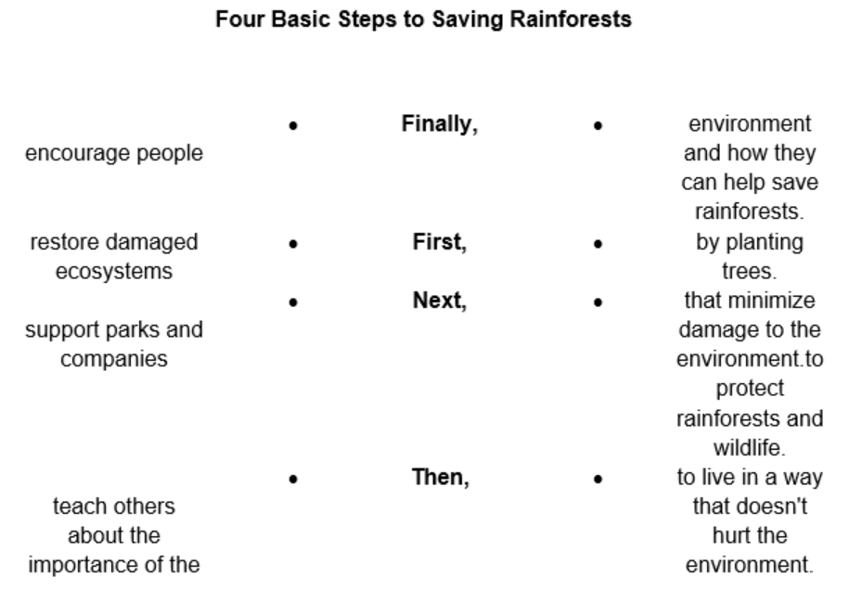 

Annex 3

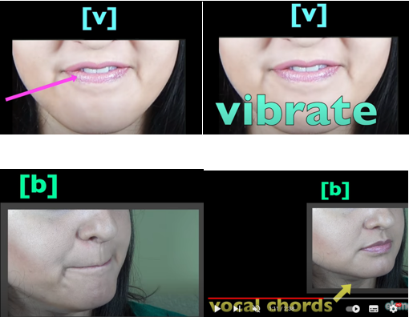

Annex 4

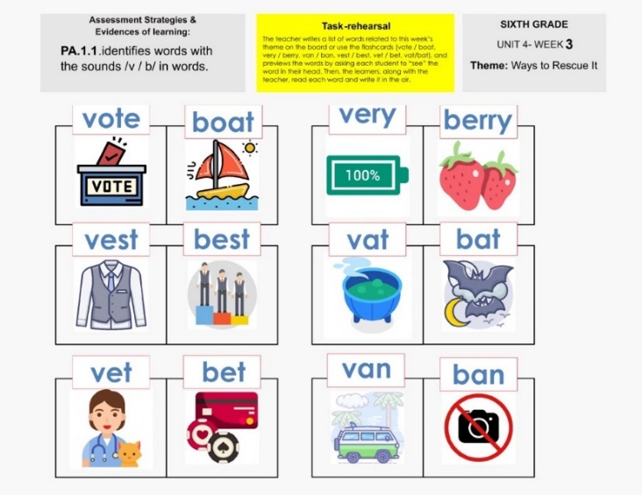 

Annex 5

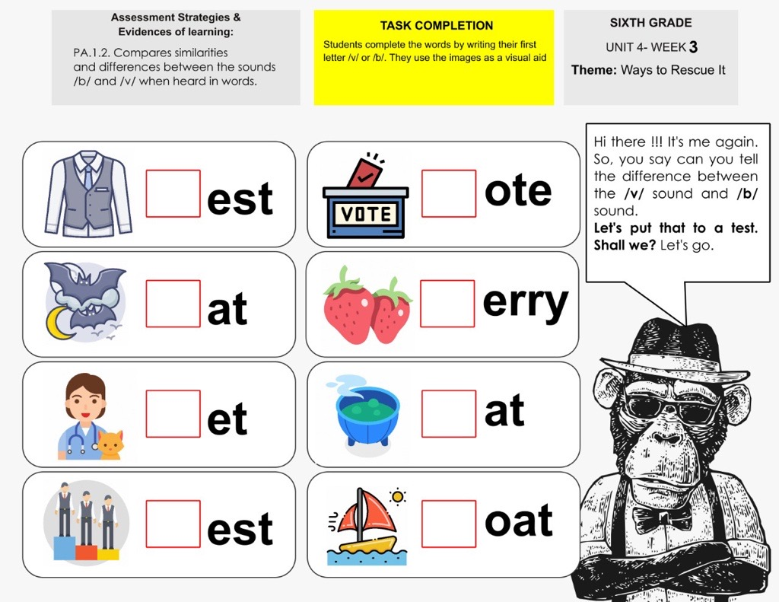 

|  |  |  |  |  |  |  |  |  |  |
| --- | --- | --- | --- | --- | --- | --- | --- | --- | --- |
| **Term: 2** | | **Level: Fifth Grade** | | | **Unit: 4** | | | **Week:4** | |
| **Domain: Socio-interpersonal** | | | | **Scenario: Rainforest Rescue** | | **Theme:** My Role in the Rainforest Rescue | | | |
| **Enduring Understanding**: Rainforests are tall, densely growing, broad-leaved evergreen trees in a tropical area with high annual rainfall. They recycle and clean water; protect against pollution and erosion, provide plants for food and medicine provide homes for many types of life forms. Rainforests are quickly being cut down mostly for wood to build houses and roads as well as making space for cattle raising and farming. | | | | | | | | | |
| **Essential Question:** What are rainforests and what happens if they disappear? | | | | | | | | | |
| |  | | --- | | **Dimensions** | | **1.** **Ways of thinking ( X )** | | **2. Ways of living in the world ( X )** | | **3. Ways of relating with others ( X )** | | **4. Tools for integrating with the world ( X )** | | | | | | | | | | |
| **Learn to Know** | | | | **Learn to Do** | | **Learn to Be and Live in Community** | | | |
| **Grammar & Sentence Frames**  Sequencing adverbs with can and should   * First, you should save water. * Next, you can educate people. * Then, you should plant trees. * Finally, we should recycle.   **Phonemic Awareness**  Practicing silent letters (kn, wr, gn)  **Vocabulary**  **4.** My Role into the Rainforest Rescue.  Verb forms   * Make a plan * Reduce * Reuse * Recycle * Save (water) * Print (on both sides) * Tell * Donate * Learn   Nouns   * Class/community projects * Species * Money   Time | | | | **Function**   * Giving advice   **Discourse Markers**  Linkers: Sequence adverbs-past tense  First, next, then, finally | | **Psycho-social**   * Discriminating between instrumental and integrative reasons to rescue the rainforest (personal benefit vs. community benefit) * Expressing ethical and moral values when making decisions related to rainforest preservation   **Sociocultural**   * Using expressions of belief via graffiti, t-shirt slogans and catch phrases   **idioms/ phrases**   * Show your care, do your share   Save the planet. | | | |
| **Assessment Strategies & Evidences of learning**  (Diagnostic, formative, summative) | **Goals** | | | **Pedagogical Mediation/ Didactic Sequence** | | | | | **Time** |
| Learner… | Learner can | | | **Pre-teaching**  **Routine**: Checking attendance, checking in with Ls, T posts the Essential Question and Enduring Understanding and talks with the students about both of them. T shares the class agenda, etc. on the board.  **Warm up**  In the following link, you will find a video that students will watch/read: Nature Is Speaking – Julia Roberts is Mother Nature | Conservation International (CI), <https://www.youtube.com/watch?v=WmVLcj-XKnM>.  Teacher plays ***“Prison brake”*** with the class.  Students make a circle, then, they place their right index finger on the left palm of the classmates next to them. Teacher shares a secret password/phrase with the group which could be one of the following: Reduce, Reuse, Recycle, Save (water), First, Next, and Then. After that, the teacher shares a story with the class that includes the secret password/phrase. When the secret password is heard, students will try to grab their classmates’ fingers while fleeing from the hand of their adjacent colleagues. The teacher chooses a new person to be the narrator of the story, on the next round and so on.  **Activation of Prior Knowledge**  Teacher writes the following paragraph on the board:  If you want to rescue the rainforest, this is what you should do: First, you should save water. Water is not only expensive but is becoming more and more scarce (= difficult to find). Then, you must plant trees. Trees produce oxygen and clear the air from Co2. Next, you should reduce, repair, and recycle all the products you use and buy daily. Finally, you must educate others about the importance of rescuing the rainforests.  Then, the teacher encourages the students to read along each sentence while pausing on those words/phrases that are going to be used as “key words” during this week.  **Modeling**  Teacher encourages the students to speak about other ways to rescue the rainforest while writing their ideas on the board. Students then read their ideas from the board.  **Clarifying**  Students copy the ideas from the board onto a worksheet that has a paragraph layout similar to the text used by the teacher for the activation of the prior knowledge**. (Annex 1)** They make sure to order their ideas in a way that follows a logical sequence. Once finished they receive feedback from teacher and classmates as a form of clarification.  **Paragraph layout for the students to write down their ideas from the board.** | | | | | 40 minutes |
| **R.1.** Recognizes readings, analyzes and enjoys texts.  **R.1.1.** recognizes much of what is written in short, simple texts on subjects related with rainforest preservation and personal responsibility.  **R.1.2.** examines the main points of texts for making decisions and recommendations about rainforest preservation and personal responsibility.  **R.1.3.** connects personal feelings and experiences with the texts read about rainforest preservation and personal responsibility. | **R.1.** comprehend reading, analyze and enjoy texts. | | | **PRE-TASK**  The teacher introduces the goal of the lesson.  Students play “**Extreme Rock Paper Scissors**”. The class is divided in two teams. Teacher places marks on the floor in a way of a path, each team lines up in the opposite ends of the path. At the teacher’s command, a member of each team starts hopping their way towards the opposite direction. When students meet, they play “Rock Paper, Scissors” to determine which student continues moving and which one needs to go back to the starting point. In order to move forward, the winner must answer a question by the teacher regarding the ideas reviewed in the previous section. Students can use the worksheet from the “Clarifying” section to reply to the teacher.   * What should we do to rescue the rain forest? * Mention one action that will help to rescue the rainforest? * Which action do you thing we need to do first and which one we need to do after that?   **Task-rehearsal**  Students read the article entitled; Rainforest preservation and personal responsibility. Then, they will recognize by highlighting on yellow those ideas in the text that talk about the actions that governments, organizations and conservation groups are doing to rescue the rainforest. They will highlight on red, the actions that students can do to help preserving the rainforest. (Annex 2)  **Article entitled; Rainforest preservation and personal responsibility. Students will recognize by highlighting on yellow those ideas in the text that talk about the actions that governments, organizations and conservation groups are doing to rescue the rainforest.**  **Task completion**  In pairs, students read the text again, and they will complete a chart with the main projects Costa Rica is developing to protect the rainforest and the actions they are performing. In the next column students are going to decide which of the projects are the most innovative, and which are the least innovative. Finally, they are going to make recommendations about how to improve the projects so that they can protect the forest in a more comprehensive way.   |  |  |  |  | | --- | --- | --- | --- | | Name of the project | Main characteristics | Mark with + the most innovative project and with a – the least innovative ones | Write one recommendation to each | |  |  |  |  | |  |  |  |  | |  |  |  |  | |  |  |  |  |   Next, they will have a conversation with their pair about recommendations and feelings they have towards the preservation of the rainforest. So they can make decisions and recommendations on their own by taking personal responsibility.  **Task assessment**  Students complete the survey about the Text from the previous section in which they’ll connect specific ideas from the text with their feelings. (Annex 3)  Survey about the text read on the previous section  Students will exchange surveys with a classmate and read to the class what his/her classmates feel about the ideas presented on the survey.  Then as volunteers, students explain to the class the main points of the reading they understood and can even recommend other texts or ideas about this topic. | | | | | 40 minutes |
| **R.PA.3.** read with fluency and accuracy.  **R.PA 3.4.** reads words and sentences related with silent letters (kn, wr, gn) with good pronunciation. | **R.PA.3.** read with fluency and accuracy.  . | | | **Pre-task**  The teacher introduces the goal of the lesson.  Students are going to watch/listen the video Silent Letters wr, kn, gn EDITED and (taken from, Letras mudas: wr. kn, gn, [Sellika Reese](https://www.youtube.com/c/SellikaReese)), <https://www.youtube.com/watch?v=JMq61QPyi_E>  Teacher provides additional explanation if required.  **Task-rehearsal**  The teacher will read the words from the worksheet and the students will listen to them. Then students will repeat after the teacher and read words from the worksheet with good pronunciation. (Annex 4)  **Words to read knight wrench write wrong wrist knew gnome wren wrote knit wreck note**  **Task completion**  Students complete the words with their corresponding initial silent letters (kn, wr, gn). (Annex 5)  **A worksheet to complete with the silent letters (KN, wr, gn) and to read them with good pronounciation. ---en ---ome ---it ---ote ---ote ___eck ___ench ___ight ___ong ___ite ___ew ___ist**  Students will make a sentence using the words, they will read the sentences in front of the class with good pronunciation.  **Task assessment**  Students will make a draw of the sentence they read to the class. | | | | | 40 minutes |
| **W.3.** Applies conventions of standard English (e.g., advertisement, labeling a photo essay).  **W.3.1**.uses capital letters at the beginning of sentences, proper nouns and first person singular when writing a description of actions.  **W.3.2.** writes a period at the end of sentences describing actions.  **W.3.3**.writes sentences describing actions using correct grammar and spelling. | **W.3.** apply conventions of standard English | | | **Pre-task**  The teacher introduces the goal of the lesson.  The teacher will bring to the class some reusable magazines and old papers and she is going to give an example of what the students will do today. She is going to take three pictures, For example:  wooden bridge over the Celeste river Taken from: <https://www.kimkim.com/c/costa-rica-self-drive-adventure-rainforests-mountains-beaches-15-days>  Waterfall at Celeste Rivertaken from: <https://www.costarica.com/attractions/celeste-river-waterfall>  Celeste River from the airtaken from: https://www.riocelestehideaway.com/  Then teacher will explain the students the following writing task:  Task: a Photo description of a family trip to the rainforest  You are going to make a photo description that includes the following:   * A title * An outline * Pictures of activities in the forest. * A description of its content with complete sentences. * All the sentences must have correct grammar, capitalization and punctuation. * Make sure that words are well-spelled.   See. (Annex 6)  Example: The Rainforest at Río Celeste.   |  |  | | --- | --- | |  | I went with my family to the Rain forest in Río Celeste. | |  | We walked a lot and cross a wooden bridge. | |  | We saw a wonderful waterfall. I was so happy! |   **Task-rehearsal**  The teacher will tell the students that they will make a photo description. They will have to think about a trip they did with their family to the forest or national park. Students will look for three pictures to start writing the sentences. They will make sure they are using proper capital letters and periods at the end of each one.  It is recommendable to make an outline before writing the sentences. The outline can include the following categories: place visited, activities done, flora and fauna of the place, feelings experienced.  **Task completion**  Students working in pairs, based on the outline, they will create their photo description. They will check that each sentence they wrote for describing this special trip have a period at the end  Students in pairs will edit the sentences they wrote, and they will check that they use the correct grammar and spelling, punctuation and capitalization  **Task assessment**  Students will share their work with the rest of the class and they will paste it on the English board so all the students can read their photo description.  They can use the following checklist to assess their task.  **Peer and self-assessment checklist**   |  |  |  |  | | --- | --- | --- | --- | | He/she can | Not achieved yet | In progress | Achieved | | The photo description has an album. |  |  |  | | There is an outline as an organizer of ideas. |  |  |  | | The photo album includes several pictures. |  |  |  | | The sentences use correct grammar. |  |  |  | | All words are correctly spelled. |  |  |  | | | | | | 40 minutes |
| **Integrated Mini-Project** | | | | | | | | | **Time** |
| Phase: \_\_\_4, 5 and 6\_\_\_\_   * The students will work on their groups making the final part of the presentation. * The teacher can give them ideas and guide them while giving feedback to the groups. * On week 5 the students will practice the pronunciation of the presentation, as the teacher give feedback to the groups. * On week 6 the students will present their mini-projects. * Teacher will have a place on the classroom where the students can exhibit their mini-projects. | | | | | | | | | 40 minutes |
| **Reflective Teaching** | | | | | | | | | |
| What worked well | | | What didn’t work well | | | | How to improve | | |
| **Enduring Understanding Reflection** | | | | | | | | | |
|  | | | | | | | | | |

|  |  |  |  |
| --- | --- | --- | --- |
| **Learner Self-Assessment** | | | |
| ***I can*** | ***Resultado de imagen para happy emoji***  ***Achieved*** | ***C:\Users\mcastilloh\Downloads\Grinning-Face-with-Smiling-Eyes.png***  ***In progress*** | ***C:\Users\mcastilloh\Downloads\descarga.jpg***  ***Not achieved yet*** |
| **R.1.1.** recognize much of what is written in short, simple texts on subjects related with rainforest preservation and personal responsibility. |  |  |  |
| **R.1.2.** examine the main points of texts for making decisions and recommendations about rainforest preservation and personal responsibility. |  |  |  |
| **R.1.3.** connect personal feelings and experiences with the texts read about rainforest preservation and personal responsibility. |  |  |  |
| **R.PA 3.4.** reads words and sentences related with silent letters (kn, wr, gn) with good pronunciation. |  |  |  |
| **W.3.1**.uses capital letters at the beginning of sentences, proper nouns and first person singular when writing a description of actions. |  |  |  |
| **W.3.2.** writes a period at the end of sentences describing actions. |  |  |  |
| **W.3.3**.writes sentences describing actions using correct grammar and spelling. |  |  |  |

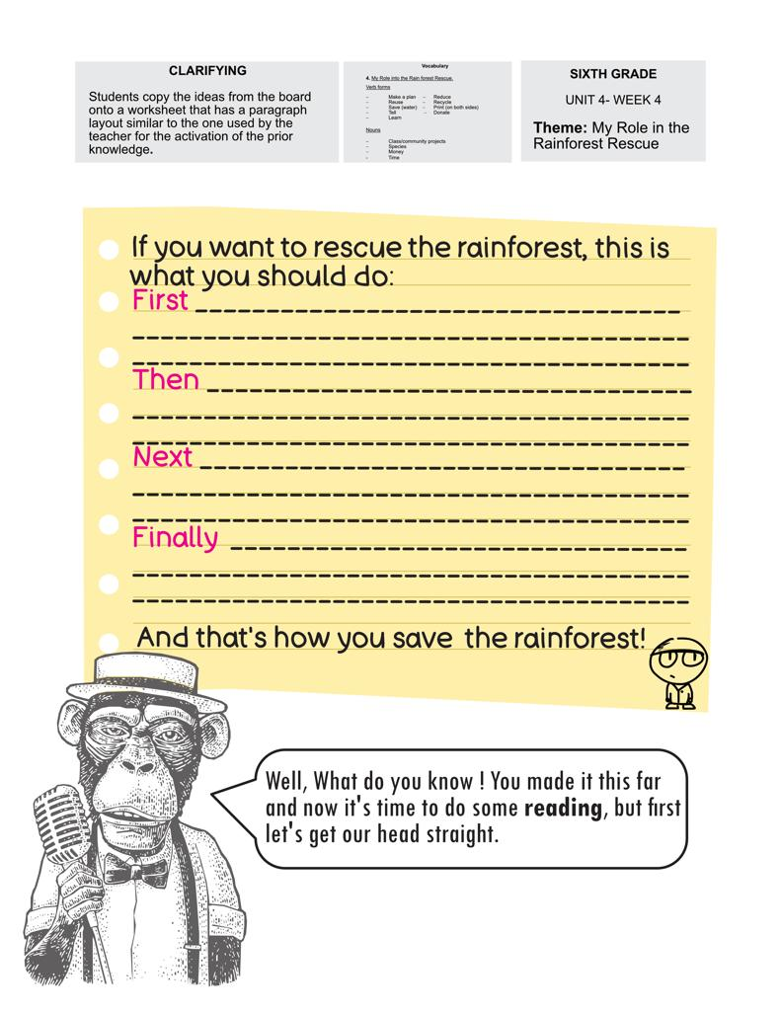Annex 1

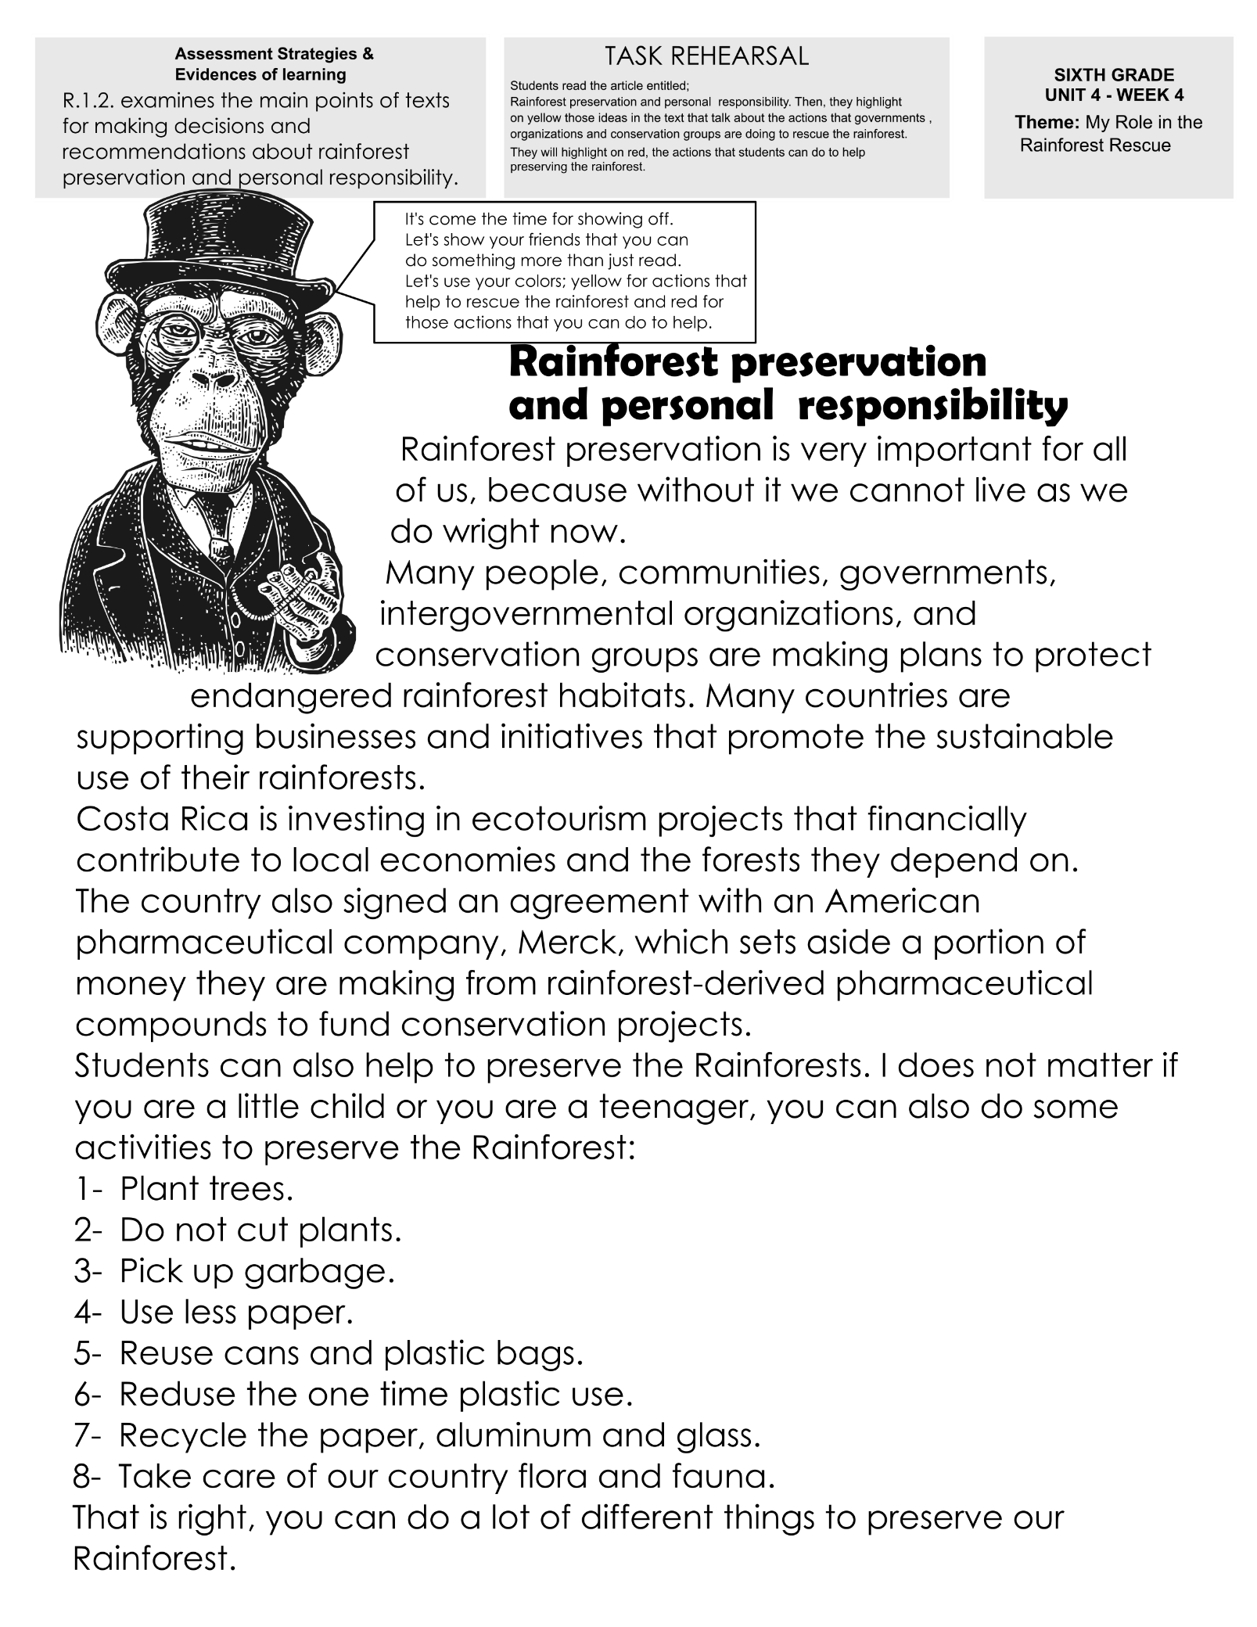***Annex 2***

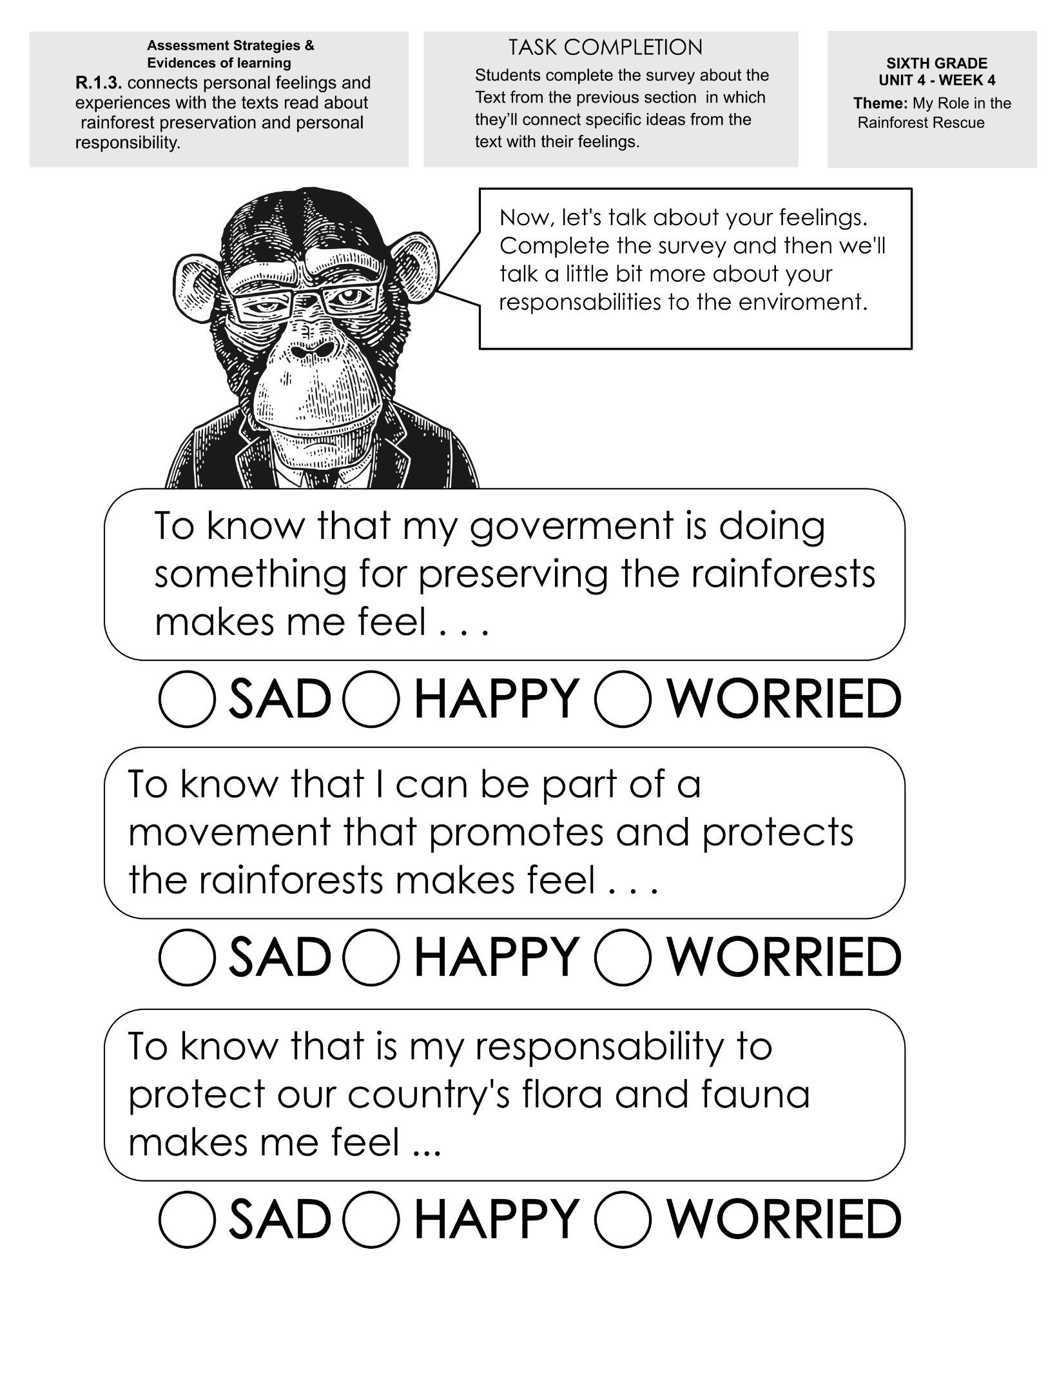***Annex 3***

***Annex 4***

***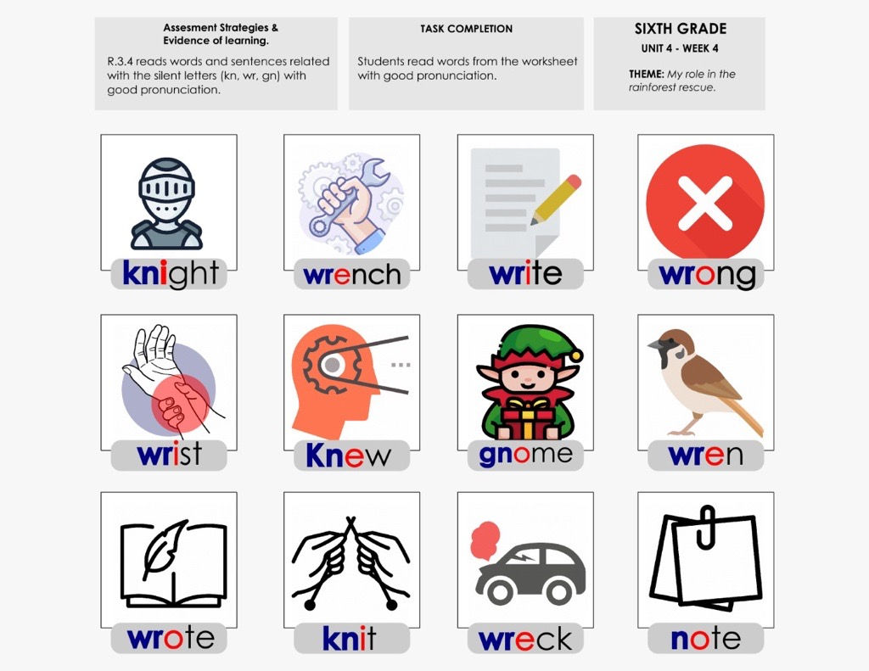 Annex 5***

***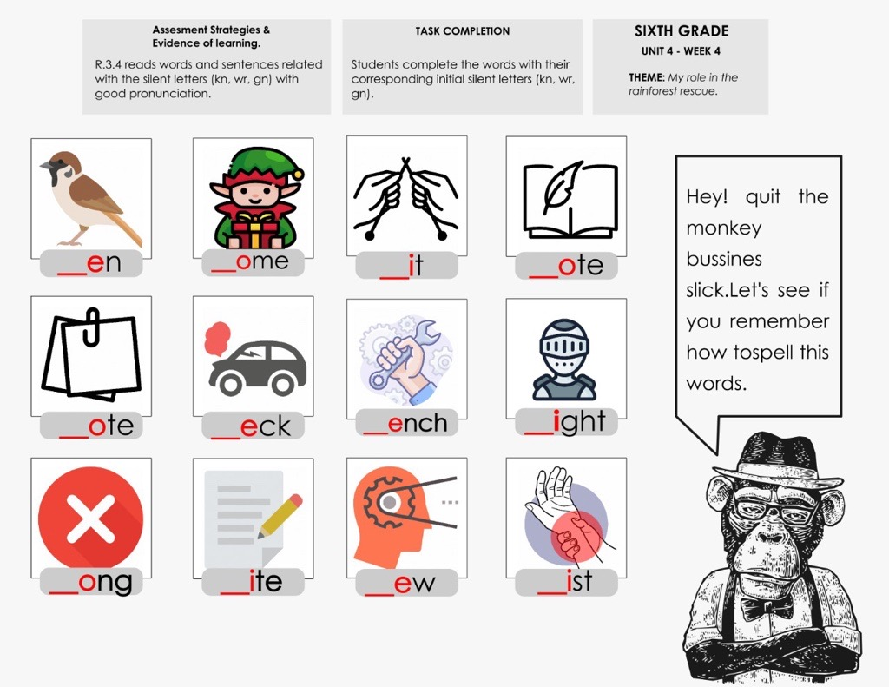***

how to spell this

Annex 6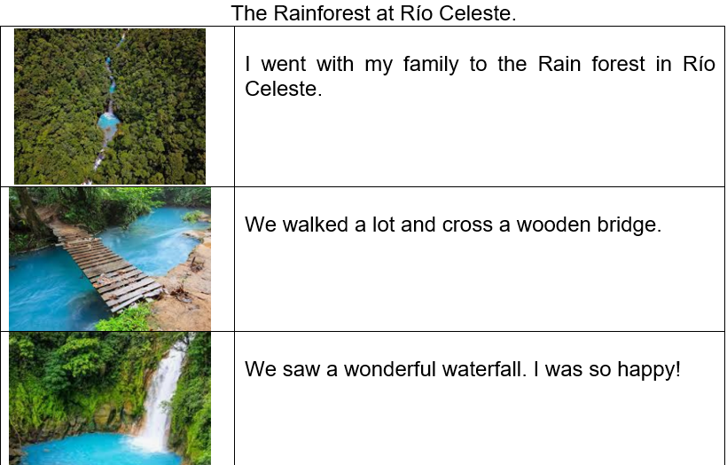

***Links used in this unit***

Video the song **“Anthem for the Amazon”** <https://www.youtube.com/watch?v=ZKumZJPClec>

Video “How can we help protect the rainforests?” [https://www.youtube.com/watch?v=gTKzoMuW-s4](https://www.youtube.com/watch?v=gTKzoMuW-s4%20)

Costa Rican Rainforest <https://www.youtube.com/watch?v=QbhCpfxsod8>.

Video entitled **Layers of the Rainforest** [**https://www.youtube.com/watch?v=7gHXoDPHTLw**](https://www.youtube.com/watch?v=7gHXoDPHTLw) **.**

Rainfall <https://ggwash.org/images/posts/_resized/42915090990_21fd8df572_k.jpg>

Climatehttps://digitalprojects.davidson.edu/earthday2020/wp-content/uploads/2020/04/stakeholder-3-2.png

Rainy https://3.bp.blogspot.com/-XEBfGqYKGT0/XHHSj1j9WFI/AAAAAAAAk1k/RFtmy4L3hIEDcMixIjeo0z\_a4btiAIZigCLcBGAs/s1600/Rainy%2BNight1.png

Cloudy https://images.pexels.com/photos/1818/sky-clouds-cloudy-forest.jpg?cs=srgb&dl=sky-clouds-cloudy-forest-1818.jpg&fm=jpg

Flora and fauna https://www.youtube.com/watch?v=QbhCpfxsod8

Canopyhttps://www.google.com/url?sa=i&url=https%3A%2F%2Fwww.arenalcanopy.com%2Farenal-canopy-espa%25C3%25B1ol%2Farenal-mundo-ventura%2F&psig=AOvVaw1BKGXyZjBiHWCfRkf8n61t&ust=1653147140427000&source=images&cd=vfe&ved=2ahUKEwjw2-aRs-73AhXyYjABHZq1CwsQr4kDegUIARDCAQ

Species https://blog.amstardmc.com/discover-diverse-animals-of-costa-rica/

Warm <https://cdn.northstarmoving.com/blog/wp-content/uploads/2012/12/4101098092_6659ed07b2_z.jpg>

Dense https://www.publicdomainpictures.net/pictures/220000/velka/dense-creeper-covering-trees.jpg

Dark https://orig00.deviantart.net/6437/f/2012/319/b/f/dark\_forest\_by\_kgbistas-d5l2cq5.jpg

Tropical https://www.weekendnotes.com/im/009/03/mustsee-attractions-in-tropical-north-queensland-a1.jpg

video Why are rainforests important?, https://www.youtube.com/watch?v=zV2druTpnaA

audio at <https://youtu.be/8HTcGFMFg9k> UNIT 4 - WEEK 2 - PRE-TASK - LISTENING – YouTube

Taken and adapted from: http://www.llanhariprimary.com/resources/home\_learning/class\_7/8th\_june/Week%202%20Comprehension%20-%20Rainforest%20Calling.pdf

Taken and adapted from: https://kids.britannica.com/kids/article/rainforest/353695

video Deforestation 2-d animation, <https://www.youtube.com/watch?v=9E4j6jphTaU>.

Endangered taken from https://webenglish.se/wp-content/uploads/2020/08/List-Of-Endangered-Animals-1.jpg

Sustainable taken from https://www.onecommunityglobal.org/wp-content/uploads/2021/03/410-BUILDING-OPEN-SOURCE-SUSTAINABLE-CITIES-1197X627.jpg

Less taken from bing search

videoRainforests 101 | National Geographic, <https://www.youtube.com/watch?v=3vijLre760w>

video [b] vs. [v] | English Pronunciation Lesson, <https://www.youtube.com/watch?v=Ghb6qapA_gM>.

video Nature Is Speaking – Julia Roberts is Mother Nature | Conservation International (CI), <https://www.youtube.com/watch?v=WmVLcj-XKnM>

video Silent Letters wr kn, gn EDITED and (taken from, Letras mudas: wr. kn, gn, [Sellika Reese](https://www.youtube.com/c/SellikaReese)), https://www.youtube.com/watch?v=JMq61QPyi\_E

taken from: <https://www.kimkim.com/c/costa-rica-self-drive-adventure-rainforests-mountains-beaches-15-days>

<https://www.costarica.com/attractions/celeste-river-waterfall>

<https://www.riocelestehideaway.com/>

**Elaboración:**

Livia Gamboa Cordero, Asesora regional de inglés, Dirección Regional de San Carlos

Royner Vinicio Villalobos Rojas, docente de inglés, Dirección Regional de San Carlos

**Revisión final y edición**

Randall Centeno Hernández, Asesor nacional de inglés, Departamento de Primero y Segundo Ciclos

Ana Isabel Campos Centeno, Asesora nacional de inglés, Departamento de Primero y Segundo Ciclos